Reference number: ML-PD-001  
Issue: 1  
Revision: 1  
Date: January 2021

Preliminary design report

MARTINLARA

David Estébanez Mérida

Jaime Fernández Diaz

Álvaro González Fariña

David Huergo Perea

Noelia Martínez Figueira

Gonzalo Moreno Arriaga

Andrés Pedraza Rodríguez

Miguel Ramiro Aguirre

Pablo Romero Ramos

Ana Isabel Soria Carro

José María Vergara Pérez

TABLE OF CONTENTS

Abstract III

1 Introduction 1

1.1 Purpose 1

1.2 Scope 1

1.3 Acronyms 1

2 Applicable and Reference Documents 2

3 Mission Overview, Requirements Flowdown 3

3.1 Payload Description 3

3.1.1 Photonic Payload 3

3.1.2 Micropropulsion system 3

3.1.3 Retro-reflector array 4

3.2 Subsystems 4

3.3 Mission Requirements 5

3.4 Conformity matrix 6

4 Subsystem Analysis and Design 7

4.1 Mission Analysis 7

4.2 Mechanical Design and Structure 12

4.2.1 Attitude 12

4.2.2 Configuration 12

4.2.3 Solar arrays 14

4.2.4 Global properties 14

4.3 Communications Subsystem and Ground Segment 16

4.3.1 Ground Station Design 16

4.3.2 Satellite Design 17

4.3.3 Uplink/Downlink Budget 18

4.4 Command and Data Handling (C&DH) 21

4.5 Thermal Control Subsystem (TCS) 22

4.5.1 Thermal Analysis 23

4.5.2 Solar panels heat balance solution 28

4.5.3 Thermal Control Solution: Louvers 29

4.6 Launcher 32

4.6.1 Vega 32

4.6.2 Soyuz 32

4.7 Attitude Determination and Control System (ADCS) 33

4.7.1 Disturbance Estimation 33

4.7.2 Results 35

4.7.3 Equipment Selected 36

4.8 Electric power subsystem 38

4.8.1 Energy storage 38

4.8.2 Solar arrays 40

5 Risk Management 41

5.1 Risk Nomenclature 41

5.2 Risk Classification and Management 41

5.3 Risk Analysis 43

5.3.1 Mission risks 43

5.3.2 Communication subsystem and ground segment risks 43

5.3.3 Thermal control subsystem risks 44

5.3.4 Attitude Determination and Control System risks 44

5.3.5 Structural risks 45

5.3.6 Power risks 46

6 Conclusions 47

6.1 Mission Analysis and Launcher 47

6.2 Mechanical Design and Structure 47

6.3 Communication subsystem and ground station 48

6.4 Thermal Control subsystem 48

6.5 Attitude Determination and Control Systems 49

6.6 Power Subsystem 49

# Abstract

This project consists of a preliminary design of a technological demonstration mission which takes part in the MARTINLARA project. The mission has five main goals. The objective for the students was to learn how to concurrently develop a preliminary design of the platform that shall accomplish those goals. In order to achieve such purpose, the different subsystems (communications, mission analysis, thermal control…) has been delegated between the members of the group in pairs. Each pair has been working for almost two months on its subsystem updating continuously their results with other subsystems results converging throughout time to a compromised solution. This methodology has been possible due to the CDA (Concurrent Design Application), an application online that allows the people working in the different subsystems to share and update results, simulating a Concurrent Design Facility.

This methodology has accelerated the processes, the evolution and the convergency to a trade solution. The final result consists of the cooperation of all the members from different subsystems. Despite Payloads, every component included in the final design is a component off the shelf already used in similar missions to improve reliability and reduce cost.

# Introduction

## Purpose

The present document describes in detail the selected design choices for the mission MARTINLARA. This project has been developed to be a technological demonstrator in orbit of different technologies for its validation in a space environment. This mission includes several research fields, such as radioastronomy, photonics, Earth observation, micropropulsion…

The gradual increase in demand of space platforms for technological demonstration, has shown a real need which this project tries to fulfil. This project involves the mission analysis, to assure that the requirements are fulfilled, the development of a nanosatellite platform, to guarantee the correct functioning of every payload instrument during its lifetime, and the mission risk analysis.

## Scope

MARTINLARA tries to test different technologies for its validation in space. This goal can be divided in small objectives, whose achievement results on the mission success. The main objectives of this mission are:

1. Technological demonstration of 6 millimetric wave photonic radiometers, 3 oriented to the Earth and 3 to the sky, working in joint effort at room temperature.
2. Observation, through the photonic radiometers, of the interaction between interplanetary dust and the Earth magnetic poles.
3. Observation of the Earth ground temperature through the millimetric wave photonic radiometers.
4. Observation of the Cosmic Microwave Background through the sky oriented photonic radiometers.
5. Technological demonstration of the first Spanish plasma electric thruster of micropulse.
6. Demonstration of the nanosatellite platform for space technological demonstration.

The proposed design aims to achieve all these objectives to ensure a successful end of the mission.

## Acronyms

* ADCS: Attitude Determination and Control Subsystem.
* CMB: Cosmic Microwave Background.
* CM: Communication Subsystem
* GS: Ground Segment
* NASA: National Aeronautics and Space Administration.
* OBDH: On-board Data handling.
* TCS: Thermal Control Subsystem

# Applicable and Reference Documents

List of all references used or mentioned in the main text and may include a list of the acronyms used in the report. A change record table, like the one reported below, should be added in this section.

Applicable Documents:

* **AD1:** ECSS-E-ST-10-04-C *(Space Environment)*
* **AD2:** ECSS-E-ST-31C (*Thermal control general requirements*)
* **AD3:** 6U CubeSat Design Specification Rev.1.

Reference Documents:

* **RD1**: California Polytechnic State University, n.d. *6U Cubesat Design Specification Rev.1..* [Online]   
  Available at: https://static1.squarespace.com/static/5418c831e4b0fa4ecac1bacd/t/5b75dfcd70a6adbee5908fd9/1534451664215/6U_CDS_2018-06-07_rev_1.0.pdf
* **RD2:** Larson, J. R. W. a. W. J., n.d. *Space Mission Analysis and Design.* s.l.:Space Technology Library.
* **RD3:** Martínez, I., n.d. *Space Thermal.* [Online]   
  Available at: http://webserver.dmt.upm.es/~isidoro/index.html
* **RD4:** Naimat, R. A. a. F. A., 2018. *"Heat transfer influence of solar panel on spacecraft,".* Abu Dhabi, s.n.
* **RD5:** NASA Technology, n.d. *CubeSat Form Factor Thermal Control Louvers.* [Online]   
  Available at: https://technology.nasa.gov/patent/GSC-TOPS-40
* **RD6:** Adolph S Jursa, US Airforce Geophysics Laboratory, 1985, *Handbook of Geophysics and the Space Environment.*

# Mission Overview, Requirements Flowdown

This mission is part of the MARTINLARA project, whose main objective is the design of a space mission for technological demonstration in orbit and the development of different technologies for their validation in space, such as radioastronomy, photonics and Earth Observation or plasma micropropulsion.

## Payload Description

### Photonic Payload

The mission will include a novel technology for detecting millimeter-wave signals at ambient temperature. This technology will be implemented in six radiometers for the observation of the cosmic microwave background in the 180 GHz, 200 GHz and 250 GHz bands: 3 millimeter-wave photonic radiometers of the sky (180, 200 and 250 GHz), and three terrestrial photonic radiometers (180, 200 and 250 GHz).

The main payload can therefore be considered to consist of three pairs of radiometers (depending on the working band), each connected to an antenna via a waveguide. The radiometers will operate in pairs, with the objective of cross-calibrating the measurements. One of them shall point to Zenith (sky radiometer) and the other one shall point to Nadir (terrestrial radiometer).

At a design level, we can consider the antennas as a flat disk, with a surface of 70, 60 and 50 mm2, for the 180, 200 and 250 GHz radiometers respectively, with a thickness of 5 mm.

We can summarize the radiometers in:

* 1st pair: 180 GHz à 1 sky photonic radiometer (Zenith) + 1 terrestrial photonic radiometer (Nadir). Surface: 70 mm2. Thickness: 5 mm
* 2nd pair: 200 GHz à 1 sky photonic radiometer (Zenith) + 1 terrestrial photonic radiometer (Nadir). Surface: 60 mm2. Thickness: 5 mm
* 3rd pair: 250 GHz à 1 sky photonic radiometer (Zenith) + 1 terrestrial photonic radiometer (Nadir). Surface: 50 mm2. Thickness: 5 mm

### Micropropulsion system

The electric micropropulsion system carried by the satellite should be used in the last phase of the mission, to avoid interferences with the objectives of the main payload. It requires a full unit of the satellite to be accommodated, which should have at least one face pointing outside the satellite and free of obstacles. The total weight of the system is 1 kg, and its maximum power consumption is 20 W. The purpose of the engine is of technological demonstration, so the satellite cannot take advantage of it for orbital or attitude corrections.

### Retro-reflector array

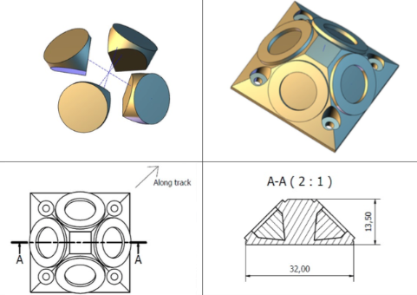The array shall be fixed on the external structure of the nanosatellite, allowing the measurement of the distance between the satellite and the terrestrial SLR (Satellite Laser Ranging) stations, to establish the orbit parameters.

**Figure 4.1.1**: Retro-reflector array. Assembled and unassembled

**Table 4.1.1**: Retro-reflector array. Assembled and unassembled

The array is formed by four retro-reflectors in a pyramidal arrangement and must be installed on the Nadir side of the nanosatellite surface. It must be ensured that only two retro-reflectors contribute to the signal retro-reflection from the SLR station. Therefore, the diagonal of the base should be aligned with the trajectory. The retro-reflectors are passive systems, and the mass of system is 20 g.

## Subsystems

For the development of the mission, a preliminary study has been made, dividing the satellite in the following subsystems:

* Mission analysis
* ACDS
* Launcher
* Power
* Thermal control
* Communications
* Structure/configuration

Each of them is fully explained in section 5.

## Mission Requirements

The mission technical requirements are the following ones:

* **R-010** *(Requirement):* The S/C shall comply with the CubeSat standards.
* **R-020** *(Requirement):* The S/C shall be a 6 units CubeSat maximum.
* **R-030** *(Requirement):* The orbit altitude shall be 550 km as maximum.
* **R-040** *(Requirement):* The orbital plane cannot contain the Earth-Sun radio-vector.
* **R-050** *(Requirement/Goal):* Each pair of twin radiometers (Nadir and Zenith pointing) shall operate simultaneously for cross-calibration purposes (Goal: more than one pair).
* **R-060** *(Requirement):* The radiometers shall take measurements with each radiometer pair for 2 orbits.
* **R-070** *(Requirement/Goal):* The radiometers shall take measurements during 1 month (splitting this time among the three radiometer pairs) (Goal: Three months).
* **R-080** *(Requirement):* Platform shall measure and keep, during operation, the external sides of the radiometers at an operational temperature range of 11-21°C, being 16°C the optimum temperature for operation. The survival temperature range is within -20°C to +50°C.
* **R-090** *(Requirement): T*he radiometers Nadir antennas shall have a FOV (Field of View) of 60 deg (± 1 deg) half angle along its normal free of the Sun and spacecraft obstacles during operation.
* **R-100** *(Requirement):* The radiometers Zenith antennas shall have a FOV of 90 deg (± 1 deg) half angle along its normal free of the Sun, Earth and spacecraft obstacles during operation.
* **R-110** *(Requirement):* The Sun penetration in the FOV of each Nadir antenna shall be recorded as a function of time.
* **R-120** (*Requirement*): The Sun and Earth penetration in the FOV of each Zenith antenna shall be recorded as a function of time.
* **R-130** (*Requirement*): Measurements with each Nadir antenna shall be taken over a circular area of 500 km around the South (North) Magnetic Pole.
* **R-140** *(Requirement):* Nadir antennas shall observe an Earth projected area (spot) of a maximum of 25 km of semi-major axis.
* **R-150** *(Requirement):* Deviation from Nadir direction shall be, as a maximum, of ± 5 deg during measurement.
* **R-160** *(Requirement):* The 3-axis pointing accuracy of the satellite shall be of at least 1 deg (Goal: 0.1 deg).
* **R-170** (*Requirement*): The 3-axis attitude determination shall be known with an accuracy of 0.1 deg with respect to Nadir (Goal: 0.05 deg).
* **R-180** (*Requirement*): The absolute position of the spacecraft shall be determined with accuracy better than 10m RMS.
* **R-190** (*Requirement*): Spacecraft shall carry and service the experimental UC3M-μPPT.
* **R-200** (*Requirement*): Spacecraft shall carry and service the retro-reflector system.

## Conformity matrix

|  |  |
| --- | --- |
| **Requirement** | **Accomplished** |
| R-010 | Yes |
| R-020 | Yes |
| R-030 | Yes |
| R-040 | Yes |
| R-050 | Yes |
| R-060 | Yes |
| R-070 | Yes, but three months not achieved |
| R-080 | Yes |
| R-090 | Yes |
| R-100 | Yes |
| R-110 | Yes |
| R-120 | Yes |
| R-130 | Yes |
| R-140 | Yes |
| R-150 | Yes |
| R-160 | Yes |
| R-170 | Yes |
| R-180 | Yes |
| R-190 | Yes |
| R-200 | Yes |

**Table 3.4.1**: Conformity matrix

# Subsystem Analysis and Design

Description of each subsystem and any other relevant part of the mission. Assumptions, computations, design choices and results should all be documented. The justified trade-off analysis for each subsystem is also included here, referencing the other sections (and their trade-offs) when necessary.

## Mission Analysis

In this section, the orbit followed by the CubeSat will be analyzed, as well as a detailed description of the payload constraints. Besides this, an analysis of the different accesses needed will be included.

The main constraints, with impact in the needed orbit, are the following ones:

* R-030: the orbit altitude shall be 550 km as maximum.
* R-040: the orbital plane cannot contain the Earth-Sun radio vector.
* R-060: The radiometers shall take measurements with each radiometer pair for 2 orbits.
* R-070: the radiometers shall take measurements for 1 month (splitting this time among the three radiometer pairs) (Goal: Three months).
* R-090: the radiometers Nadir antennas shall have a FOV (Field of View) of 60 deg (± 1 deg) half angle along its normal free of the Sun and spacecraft obstacles during operation.
* R-100: the radiometers Zenith antennas shall have a FOV of 90 deg (± 1 deg) half angle along its normal free of the Sun, Earth and spacecraft obstacles during operation.
* R-130: measurements with each Nadir antenna shall be taken over a circular area of 500 km around the South (North) Magnetic Pole.

These constraints will determine the orbit used. Some of them are quite restrictive, especially, the ones that include Sun restrictions.

The solution selected to meet these requirements is a **Sun-Synchronous LAN18** (also known as a Dusk-dawn orbit) orbit with a local time of ascending node at 18:00 (and a local time of descending node at 06:00). There are several reasons that support this decision:

1. Sun Synchronous orbits always maintains a constant orientation of the orbital plane with respect to the solar meridian. This means that R-040 shall not be a problem.
2. Sun Synchronous orbits usually are nearly polar orbits (it depends on the altitude), which is beneficial for R-130 (measurements over the poles).
3. By setting the ascending node at 18:00, the orbit is tilted towards the Sun in the north pole, and away from it in the south, which allows to make observations in the south pole fulfilling requisite R-100. As the magnetic north pole is farther from the geographical south than the magnetic south from the north, is more difficult to obtain adequate measures in the first one.

The following decisions are related with the orientation of the sensor. In Figure 4.1.1 we can see what would be consider a free of the Sun situation and one situation which is not.

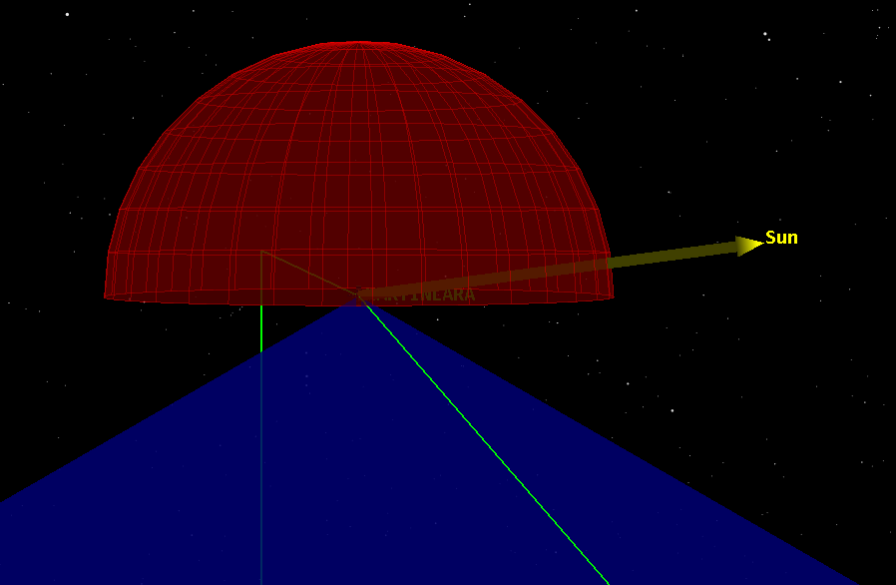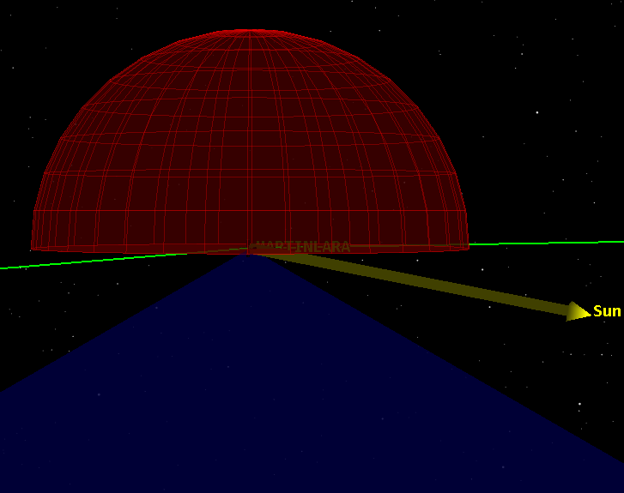

**Figure 4.1.1**: Left side shows a situation which does not meet R-100, right side shows a situation which does.

This is a very restrictive requirement for the Zenith sensor, since there is no altitude (that also meets R-030), that can take measurements without the Sun interfering with the sensor. To mitigate this effect, the proposed solution is to give the sensor a certain inclination, as the Figure 4.1.2 shows. This inclination shall allow the sensor to meet the Sun constraint at some parts of the years, although it depends on the season of the year (view Figure 4.1.2).

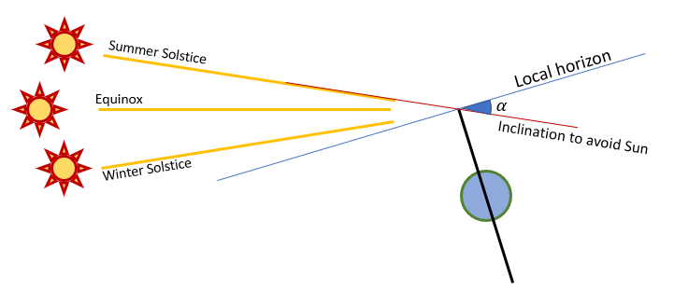

**Figure 4.1.2**: Scheme of the proposed solution to mitigate Sun constraint

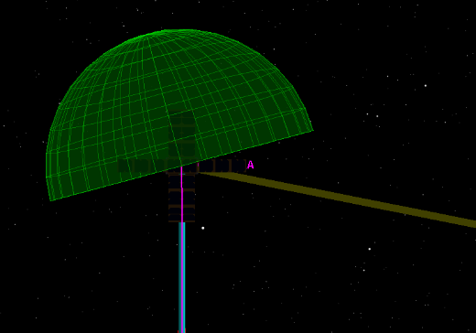

**Figure 4.1.3**: Scheme of the Zenith sensor inclination

The selection criteria are the following ones:

* The inclination must allow the satellite to meet R-100.
* The duration of the measurements must be, at least, one month in total (R-070). Consequently, the inclination of the sensor must be enough to have the required time needed to meet R-070 throughout the mission.
* Structure: to obtain zenith sensor inclination, a correct structure configuration must be assured.

Considering these specifications, the given inclination to the zenith sensor shall be 15°. This value has been selected for several reasons:

First of all, it is not an excessive inclination, therefore, there should be no important structure inconvenient. Secondly, this will give a period of time between 5 Jan – 8 Apr, 4 Sep – 1 Dec, approximately (with little variation with the altitude of the satellite), free of the Sun interference.

To sum up, there will be enough time throughout the mission to take measurements while meeting the constraints given.

Therefore, the zenith sensor parameters shall be:

* FoV = 180°
* Azimuth: 90°
* Elevation: -75° (15° of inclination)

The next point is the mission duration. The main constraint here is the electrical power subsystem, which gave a maximum eclipse time. For our orbit and different altitudes, the eclipse period is:

|  |  |  |  |
| --- | --- | --- | --- |
| h (km) | Begin | End | Max. Duration (s) |
| 550 | 4 May | 10 Aug | 1261 (June) |
| 500 | 1 May | 13 Aug | 1323 (June) |
| 450 | 29 Apr | 15 Aug | 1387 (June) |

**Table 4.1.1**: Eclipse periods (obtained with STK)

In view of this, the satellite would not survive with this eclipse duration, consequently, all measurements must be taken before. Therefore, it can be determined that the end of the mission shall be about 15th April, since the last measurements were taken about 10th April (due to the Sun constraints of the sensors), and the next window would open in September. We could still interact with the satellite until the maximum eclipse time for our power subsystem takes place (view Power subsystem section) but we could not make measurements. **Mission operation shall be between 1 - September to 15-April**.

The number of contacts that met simultaneously requisites R-090, R-100 and R-130 has been obtained with STK. For an orbit of 550 km height, the contacts obtained are:

|  | Only Magnetic South Pole | Only Magnetic North Pole | Both Poles |
| --- | --- | --- | --- |
| Individual contacts | 1 | 347 | 348 |
| Double contacts | 17 | 0 | 17 |
| 3 consecutive contacts | 169 | 0 | 169 |
| Duration of measurements (h) | 862.73 | 552.34 | 1415.07 |
| Duration of measurements (d) | 35.94 | 23.01 | **58.95** |

**Table 4.1.2**: Blocks of contacts and duration of the mission for an altitude of 550 km, considering only the accesses with the magnetic south pole, only the accesses with the magnetic north pole, and finally, considering the accesses with both poles, throughout the mission.

For an average altitude of 500 km, the contacts are:

|  |  |  |  |
| --- | --- | --- | --- |
|  | Only Magnetic South Pole | Only Magnetic North Pole | Both Poles |
| Individual contacts | 0 | 328 | 322 |
| 3 consecutive contacts | 123 | 0 | 123 |
| 4 consecutive contacts | 61 | 0 | 55 |
| 5 consecutive contacts | 0 | 0 | 6 |
| Duration of measurements (h) | 966.66 | 517.23 | 1483.9 |
| Duration of measurements (d) | 40.27 | 21.55 | **61.83** |

**Table 4.1.3**: Blocks of contacts and duration of the mission for an altitude of 500 km, considering only the accesses with the magnetic south pole, only the accesses with the magnetic north pole, and finally, considering the accesses with both poles, throughout the mission.

And for 450 km:

|  |  |  |  |
| --- | --- | --- | --- |
|  | Only Magnetic South Pole | Only Magnetic North Pole | Both Poles |
| Individual contacts | 1 | 345 | 322 |
| Double contacts | 1 | 0 | 1 |
| 3 consecutive contacts | 46 | 0 | 46 |
| 4 consecutive contacts | 135 | 0 | 111 |
| 5 consecutive contacts | 0 | 0 | 24 |
| Duration of measurements (h) | 1062.21 | 538.12 | 1600.32 |
| Duration of measurements (d) | 44.25 | 22.42 | **66.68** |

**Table 4.1.4**: Blocks of contacts and duration of the mission for an altitude of 450 km, considering only the accesses with the magnetic south pole, only the accesses with the magnetic north pole, and finally, considering the accesses with both poles, throughout the mission.

The duration of the mission has been calculated as the sum of the duration of every orbit on which a valid observation is made, or:

Duration = number of contacts x orbital period

It can be seen how the duration of the measurements increases at lower altitudes.

Due to the high inclination of the orbit and the proximity of the magnetic south pole to the geographic north pole, the accesses to the aforementioned pole are frequent and there are several groups of consecutive passes. However, the magnetic north pole is farther from the geographic south pole, so the accesses to this one is scarcer and non-consecutive.

Despite this, requisite R-070 can be fulfilled taking into account only the measures related to the geographic north, and, when considering valid the measures in both poles, the minimum duration of the mission is almost doubled.

There is, however, only one occasion on which the satellite will fly consecutively over the two poles. In any other occasion, all the clusters of accesses are related to the geographical north pole.

Considering all this, the altitude of the orbit is flexible, this is, all over the range of 450 km – 550 km, the requirements are met, and the different changes in speed, period time, communication accesses, etc. do not significantly affect other subsystems. Nevertheless, lower altitudes than 450 km have a significant influence of the atmosphere. To sum up, it is more likely that the altitude shall be defined by the launcher used. Based on the latest Sun-Synchronous CubeSats launches altitudes (for example, VEGA VV16 deployed several CubeSats 6U at 530 km) and to consider the most adverse situation (referring to the accesses to the poles), the altitude selected shall be 550 km (the highest possible according to the requirements).

|  |  |
| --- | --- |
| Orbit | Sun-Synchronous LAN18 |
| Height | 550 km |
| Inclination | 97.4° |
| Mission duration | 1 September – 15 April |

**Table 4.1.5**: Chosen orbit and mission duration.

## Mechanical Design and Structure

The chosen solution has been a 6U CubeSat. As a requirement of the mission, it was required to be a CubeSat with a maximum of six units, a four-unit CubeSat would not have enough space for all the components.

### Attitude

The satellite will orbit with its negative Y axis pointing Nadir and its X axis pointing the Sun, as it can be seen in Figure 4.2.1. Due to the lack of a self-propulsion system, the satellite needs to be placed in orbit at the moment of its deployment. According with CubeSat specifications, it will be deployed in the positive Z direction. The axis system considered is the one considered in CubeSat standards.

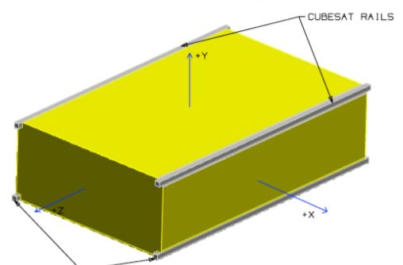

**Figure 4.2.1**: CubeSat axis system

### Configuration

On the Sun side, there will be placed the Nadir radiometers because they do not have such a strict orientation requirement with the Sun. Moreover, on the third unit of the Sun side, there will be the GPS, the magnetometer, two Sun trackers and the battery. The battery will be isolated and centred as possible to be the separated from the walls.

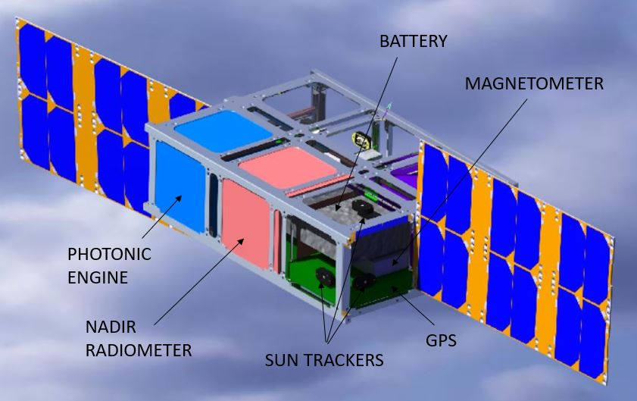

**Figure 4.2.2**: Sun-side configuration

On the other hand, on the dark side will be the Zenit radiometer, as this payload has a strict requirement of not interfering with an object in a 180-degree angle, the whole corner of the structure shall be mechanized, as it is shown in Figure 4.2.4 with an angle of 15 degrees, the orientation stablished for Zenit radiometers. It is also located in one unit the complete set of reaction wheels and magnetorquers and last one contains the computer, transceiver, and the star trackers. Every component on the dark side has been disposed considering the structure mechanisation.

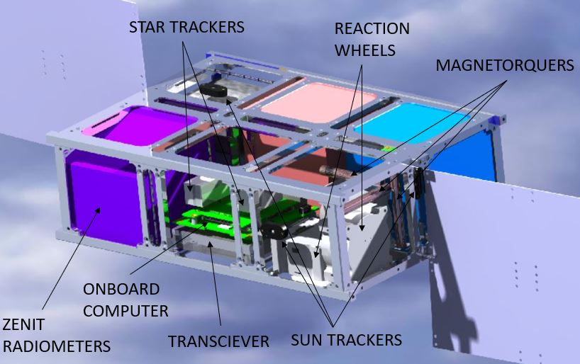

**Figure 4.2.3**: Dark-side configuration

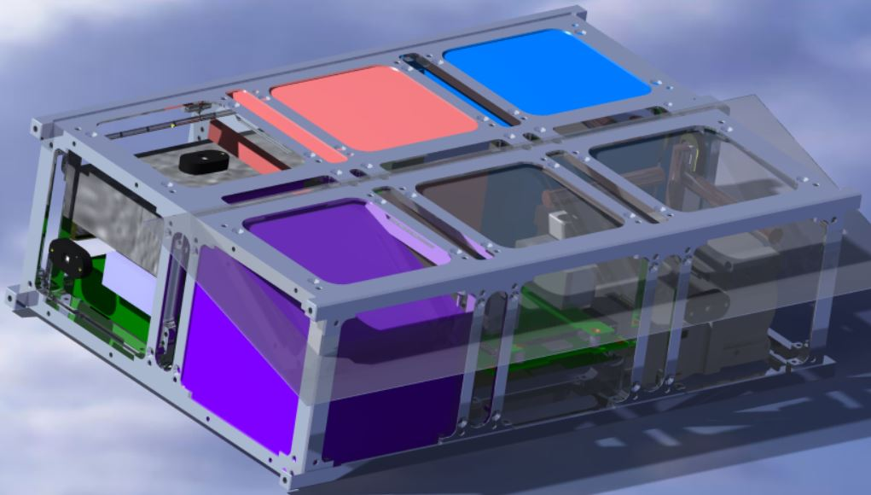

**Figure 4.2.4**: Mechanisation plane

The retroreflector exceeds 6 mm normal to surface to reduce interference with the structure. CubeSat specifications declares that any component cannot exceed more than 10 mm. Considering the solar arrays of 2 - 3 mm thick that requisite is fulfilled. Also, the Antenna exceeds 5 mm due to its geometry.

Furthermore, closing panels or louvers utilized shall be mechanised for radiometers, Sun trackers, star trackers and the photonic engine, all of them need an external access.

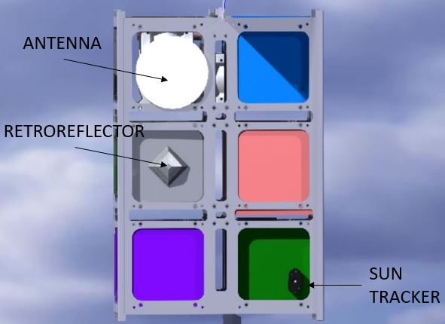

**Figure 4.2.5**: Nadir face configuration

### Solar arrays

In order to fulfil the power request from the different components there will be two solar arrays placed on the largest faces. After the deployment, the solar panels will be unfolded and oriented towards the Sun. The chosen orbit is heliosynchronous and the platform will not rotate along any axis, therefore, solar arrays will not need an active orientation system because they will be always orientated towards the Sun. Solar arrays will be place on the Y faces and attached to hinges that will unfold and torque the solar arrays as it can be seen on Figure 4.2.6.

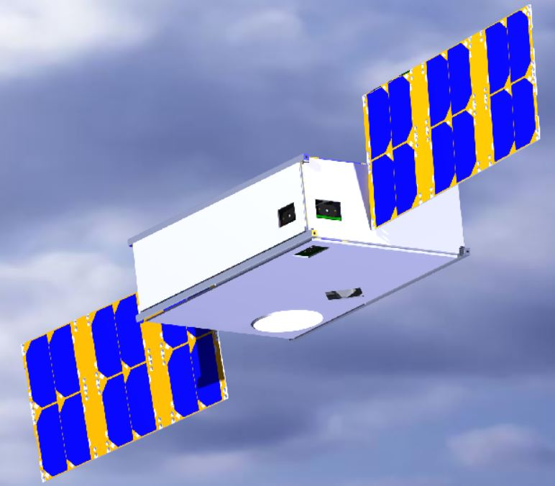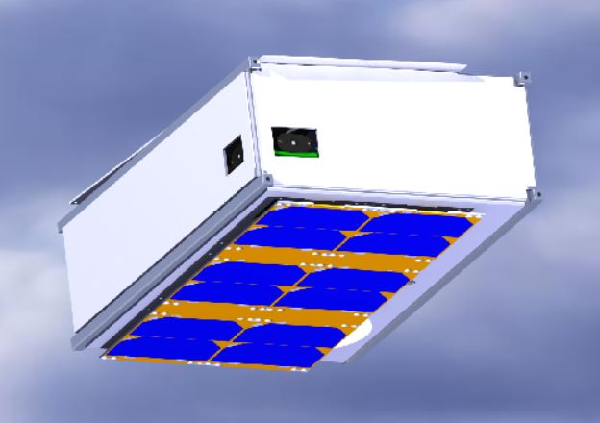

**Figure 4.2.6**: Unfolded and folded platform with louvers

In the figures it also can be seen how could be disposed the louvers, represented by the white panels. During launch louvers will be closed. Hence, they will not be in conflict with exceeding the envelope surface of the platform.

### Global properties

Accomplishing CubeSat specifications, the centre of gravity location is deviated from the geometric centre inside imposed limits.

| Axis | Deviation(cm) | Limit deviation(cm) |
| --- | --- | --- |
| X | 2,23 | 4,00 |
| Y | 0,36 | 2,00 |
| Z | 4,36 | 7,00 |

**Table 4.2.1**: Center of gravity deviation from geometric center

Finally, as it can be seen in the mass budget, the system does not exceed the imposed limit of 12 kg. Moreover, it has been taken a conservative value for the structure weight, it has been considered auxiliar structures necessary for the configuration as well as hinges, joint elements…

|  | Mass (kg) | Quantity |
| --- | --- | --- |
| Structure | 1,500 | 1 |
| Radiometer | 1,000 | 2 |
| Photonic engine | 1,000 | 1 |
| Louvers | 0,900 | 1 |
| Solar arrays | 0,410 | 2 |
| Battery | 0,298 | 1 |
| Star tracker | 0,250 | 2 |
| Reaction wheel | 0,200 | 3 |
| Transceiver | 0,191 | 1 |
| GPS | 0,130 | 1 |
| Onboard Computer | 0,100 | 1 |
| Magnetometer | 0,085 | 1 |
| Antenna | 0,050 | 1 |
| Sun tracker | 0,004 | 6 |
| Magnetorquer | 0,030 | 3 |
| Retroreflector | 0,020 | 1 |
| **Total** | **8,308** | |

**Table 4.2.2**: Mass Budget

## Communications Subsystem and Ground Segment

The primary goal of the communication subsystem is to provide a link to relay data findings and send commands from the satellite to the ground station and vice versa. It is crucial to calculate the uplink and downlink budget to ensure that the information is received intelligible with an adequate signal-to-noise ratio.

In the paragraphs that follow, the ground station, the transceiver and the satellite antenna are selected to guarantee a positive system link margin.

In designing the communication subsystem architecture, it is necessary to know what the information to be transferred is and how fast must the rate be. Our mission does not incorporate cameras; therefore, no images must be transferred, and the data is limited to text files. After comparing with similar missions, the data bit rate identified is 20 kbps and the selected frequency band is the S-band.

### Ground Station Design

The communication subsystem design process begins with the selection of a feasible ESA ground station. As it has been mentioned before, the orbit inclination is 97.4°. Thus, the ground station must be located at high latitudes in order to increase the satellite access time to the ground station antenna. For that purpose, Svalbard (Norway) has been selected as the main ground station.

|  |  |
| --- | --- |
| Location | Svalbard |
| Country | Norway |
| Longitude | 15.399 |
| Latitude | 78.228 |

**Table 4.3.1**: Svalbard ground station

The main features of Svalbard antenna can be summarized in the following tables:

| GROUND STATION (UPLINK) | | | |
| --- | --- | --- | --- |
| Parameters | | Value | Unit |
| Antenna Characteristics | | | |
| $$G_{ant, GS}$$ | Antenna Gain | 44,8 | dBi |
| $${BW}_{-3dB, GS}$$ | Half-Power Beamwidth | 0,95 | deg |
| $$θ_{e, GS}$$ | Pointing Error | 0,095 | deg |
| $$L_{θe, GS}$$ | Antenna Pointing Loss | -0,12 | dB |
| $${sen}_{GS}$$ | Radio Sensitivity | -110 | dBm |
| $$e$$ | Elevation Angle | 5 | deg |
| Transmitter Characteristics | | | |
| $$G_{Rx, GS}$$ | Transmitter Power | 53 | dBm |

**Table 4.3.2**: Ground station Uplink characteristics

| GROUND STATION (DOWNLINK) | | | |
| --- | --- | --- | --- |
| Parameters | | Value | Unit |
| Antenna Characteristics | | | |
| $$G_{ant, GS}$$ | Antenna Gain | 45,8 | dBi |
| $${BW}_{-3dB, GS}$$ | Half-Power Beamwidth | 0,85 | deg |
| $$θ_{e, GS}$$ | Pointing Error | 0,085 | deg |
| $$L_{θe, GS}$$ | Antenna Pointing Loss | -0,12 | dB |
| $${sen}_{GS}$$ | Radio Sensitivity | -126 | dBm |
| $$e$$ | Elevation Angle | 5 | deg |
| Transmitter Characteristics | | | |
| $$G_{Rx, GS}$$ | Receiver Power | - | dBm |

**Table 4.3.3**: Ground station Downlink characteristics

### Satellite Design

The next step in the design process is the selection of the satellite communication elements. In order to reduce mass and optimize space, a transceiver is chosen instead of a transmitter and a receiver.

The CubeSat S-band Transceiver from Satlab is the one chosen since it has the best features.

| SATELLITE DESIGN - TRANSCEIVER | | | |
| --- | --- | --- | --- |
| Parameters | | Value | Unit |
| General Characteristics | | | |
| $$M_{T, SAT}$$ | Transceiver mass | 0,191 | kg |
| $L_{T, SAT}×W_{T, SAT}×H_{T, SAT}$ | Transceiver dimensions | 93 x 87,2 x 17 | mm x mm x mm |
| Receiver Characteristics (TC) | | | |
| $$G_{TC, SAT}$$ | Receiver Power | 30 | dBm |
| $$P_{TC, SAT}$$ | Receiver Input Power | 0,7 | W |
| Transmitter Characteristics (TM) | | | |
| $$G_{TM, SAT}$$ | Transmitter Power | 30 | dBm |
| $$P_{TM, SAT}$$ | Transmitter Input Power | 5,9 | W |

**Table 4.3.4**: Transceiver Characteristics

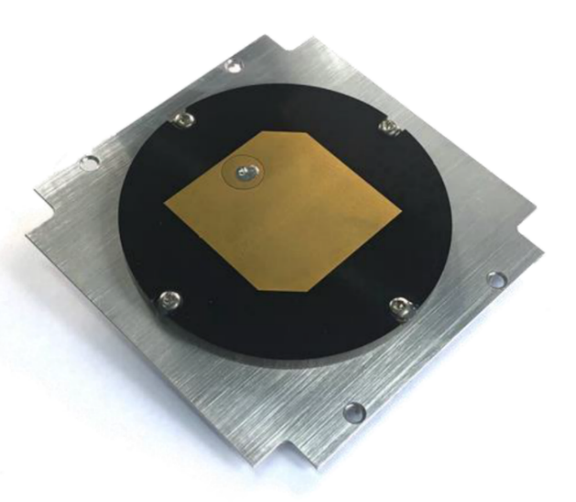

**Figure 4.3.1**: S-Band Transceiver NanoAvionics

Moreover, after a thorough analysis of the CubeSat antennas market, the chosen antenna is the S-Band Patch Antenna from ISIS.

|  |  |  |  |  |  |  |  |  |  |  |  |  |  |  |  |  |  |  |  |  |  |  |  |  |  |  |  |  |  |  |  |  |  |  |  |  |  |  |  |  |  |  |  |  |  |  |  |  |  |  |  |  |  |  |  |  |  |
| --- | --- | --- | --- | --- | --- | --- | --- | --- | --- | --- | --- | --- | --- | --- | --- | --- | --- | --- | --- | --- | --- | --- | --- | --- | --- | --- | --- | --- | --- | --- | --- | --- | --- | --- | --- | --- | --- | --- | --- | --- | --- | --- | --- | --- | --- | --- | --- | --- | --- | --- | --- | --- | --- | --- | --- | --- | --- |
| | SATELLITE DESIGN - ANTENNA | | | | | --- | --- | --- | --- | | Parameters | | Value | Unit | | General Characteristics | | | | |  | Antenna Mass | 0,1 | kg | |  | Antenna Diameter | 80 | mm | |  | Antenna height  (without connector) | 5 | mm | |  | Connector height | 8,8 | mm | | Performance | | | | |  | Antenna Gain | 6,50 | dBi | |  | Antenna Efficiency | 55% | - | |  | Half-Power Beamwidth | 100 | deg | |  | Pointing Error | 10 | deg | |  | Antenna Pointing Loss | -0,12 | dB | |  | Radio Sensitivity | -110 | dBm |   ***Table 4.3.5:*** *Satellite Antenna Characteristics* | **Figure 4.3.2**: S-Band Patch Antenna ISIS |

### Uplink/Downlink Budget

Finally, the calculation of the system margin and the total losses (both uplink and downlink budgets) are shown in Table 4.3.6 and Table 4.3.7.

| UPLINK BUDGET DESIGN | | | |
| --- | --- | --- | --- |
| Parameters | | Value | Unit |
| $$f_{U}$$ | Uplink Frequency | 2,1 | GHz |
| $${EIRP}_{ant-tx, GS}$$ | EIRP | 66,8 | dBW |
| $$L_{Tx-ant, GS}$$ | Transmitter-Antenna Losses | -1 | dB |
| $$L_{S,U}$$ | Free Space Losses | -165,53 | dB |
| - | Propagation Absorption Losses | -0,1 | dB |
| - | Polarization Losses | -0,30 | dB |
| - | Radome Losses | -1 | dB |
| $$L_{θe, GS}$$ | GS Pointing Losses | -0,12 | dB |
| **Total Losses** | | **-167,05** | **dB** |
| $$T_{SYS,U}$$ | System Noise Temperature | 614 | K |
| $$G/T_{U}$$ | Figure of Merit | -21,38 | dB/K |
| $$C/N_{0}$$ | Carrier to Noise Power Density | 76,96 | dBHz |
| $$E_{b}/N_{0}$$ | $$E_{b}/N_{0}$$ | 33,95 | dB |
| $$b_{U}$$ | Modulation | QPSK | - |
| $$E_{b}/{N_{0}}_{REQ}$$ | $E_{b}/N_{0}$ Required | 11,59 | dB |
| **System Link Margin** | | **22,36** | **dB** |

**Table 4.3.6**: Uplink Budget

| DOWNLINK BUDGET DESIGN | | | |
| --- | --- | --- | --- |
| Parameters | | Value | Unit |
| $$f_{D}$$ | Downlink Frequency | 2,25 | GHz |
| $${EIRP}_{ant, TM-SAT}$$ | EIRP | 5,5 | dBW |
| $$L_{TM-ant, SAT}$$ | Transmitter-Antenna Losses | -1 | dB |
| $$L_{S,D}$$ | Free Space Losses | -166,13 | dB |
| - | Propagation Absorption Losses | -0,14 | dB |
| - | Polarization Losses | -0,30 | dB |
| - | Radome Losses | -1 | dB |
| $$L_{θe, SAT}$$ | GS Pointing Losses | -0,12 | dB |
| **Total Losses** | | **-167,69** | **dB** |
| $$T_{SYS,D}$$ | System Noise Temperature | 190 | K |
| $$G/T_{D}$$ | Figure of Merit | 23,01 | dB/K |
| $$C/N_{0}$$ | Carrier to Noise Power Density | 59,42 | dBHz |
| $$E_{b}/N_{0}$$ | $$E_{b}/N_{0}$$ | 16,41 | dB |
| $$b_{U}$$ | Modulation | QPSK | - |
| $$E_{b}/{N_{0}}_{REQ}$$ | $E_{b}/N_{0}$ Required | 9,6 | dB |
| **System Link Margin** | | **4,81** | **dB** |

**Table 4.3.7**: Downlink Budget

Where the propagation absorption losses have been estimated dividing the zenith attenuation by the sine of the minimum elevation angle from the ground station to the satellite. On the other hand, polarization and random losses are fixed values.

The chosen uplink system noise temperature (*TSYS,U*) is a typical value in satellite communications links in clear weather and the temperatures are referred to the antenna terminal. However, the downlink system noise temperature (*TSYS,D*) is provided by the ground station.

As it can be seen, the system link margin for the uplink is 22,36 dB and 4,81 dB for the downlink. The calculations have been made in the worst-case scenario, for example considering an oversized data bit rate and that the elevation angle at which the ground station has line of sight with satellite is of 5°. Since both margins are positive, it is ensured that all the information will be received with an adequate signal-to-noise ratio.

Finally, with the purpose of validating the selected ground station, the Figure 4.3.3 represents the satellite-ground station antenna access report. As it can be seen, Svalbard ground station allows various access per day. Therefore, it is a proper election.

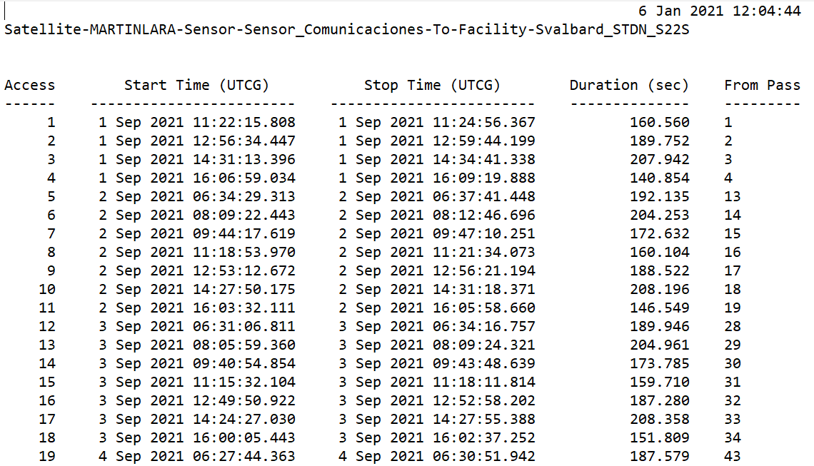

**Figure 4.3.3**: Access report

## Command and Data Handling (C&DH)

The main objective of the on-board computer is to have enough data storage to collect mission data between accesses without running out of memory. It also needs to fulfil CubeSat specifications of power consumption.

As regard the main objective, the selected computer has a data storage of 4 GB, considering an average collected data rate of 20 kB/s it is able to spend nearly 60 hours collecting data before running out of space. The average time between accesses with the Svalbard ground station is 2 hours and 10 hours during night period (source STK). Hence, the chosen solution is the *400MHz 32-bit ARM9 processor* (ISISpace), which has enough data storage for any unexpected problem and has a reduced mass, dimensions, and power consumption. It is also at TRL 9 and counts with heat sensors incorporated.

|  |  |  |  |  |  |  |  |  |  |  |  |
| --- | --- | --- | --- | --- | --- | --- | --- | --- | --- | --- | --- |
| |  |  | | --- | --- | | Mass Data Storage | 4 GB | | Dimensions | 96x94x12,4 (mm) | | Power | 400 mW | | Voltage | 3,3V | | Mass | 100 g |   ***Table 4.4.1:*** *On-Board computer properties* | **Figure 4.4.1**: 400MHz 32-bit ARM9 processor (ISISpace) |

## Thermal Control Subsystem (TCS)

The role of thermal control subsystem is to maintain all spacecraft, payload components and subsystems within their required temperature limits for each mission phase. Two limits are frequently defined: operational limits that the component must remain within while operating, and survival limits that the component must always remain within, even when it is not powered.

|  |  |  |
| --- | --- | --- |
|  | Typical Temperature Ranges (⁰C) | |
| Component | Operational | Survival |
| Batteries | 0 to 15 | -10 to 25 |
| Power Box Baseplates | -10 to 50 | -20 to 60 |
| Reaction Wheels | -10 to 40 | -20 to 50 |
| Gyros/IMUs | 0 to 40 | -10 to 50 |
| Star Trackers | 0 to 30 | -10 to 40 |
| C&DH Box Baseplates | -20 to 60 | -40 to 75 |
| Hydrazine Tanks and Lines | 15 to 40 | 5 to 50 |
| Antenna Gimbals | -40 to 80 | -50 to 90 |
| Antennas | -100 to 100 | -120 to 120 |
| Solar Panels | -150 to 110 | -200 to 130 |

**Table 4.5.1**: Typical temperature ranges of various types of components.

|  |  |  |
| --- | --- | --- |
|  | Specific Temperature Ranges (⁰C) | |
| Component | Operational | Survival |
| Radiometers | 11 to 21 | -20 to 50 |

**Table 4.5.2**: Specific temperature ranges for radiometers.

The desired temperatures are achieved by balancing the flow of heat energy across spacecraft interfaces. The power dissipation of the system combined with the orbit’s thermal environment will drive the thermal design. The system must conduct internally generated heat to the outside of the spacecraft where it can be radiated to space. To this end, both passive and active thermal control techniques exist, although from the power budget perspective, passive thermal control is always a better choice. Furthermore, passive thermal control mechanisms are generally simpler and cheaper to buy.

Therefore, to begin the design process, it is needed to know the temperature requirements of the components, the power dissipated by them and the heating environment to which the spacecraft will be exposed.

### Thermal Analysis

In order to know the temperature range in which the spacecraft will be during operation, a thermal balance of the system needs to be carried out. The satellite must fulfill the temperature margins established in the requirements, specifically the R-080 requirement that specifies that the radiometers must be kept at an operational temperature between 11 and 21 degrees Celsius. Thus, it will be possible to estimate the temperature of the system as a whole on two extreme scenarios, the hottest and coldest operation conditions, specified later on in this text. Then, if the temperature requirements are not met, the actions that must be taken to achieve them are also explained.

The external faces of the spacecraft that enclose the satellite are the boundary conditions with the outer environment and therefore control the average temperature of the system. Hence, both its orientation in relation to the main sources of heat and its thermal properties will be a key factor when carrying the thermal balance. Surface finishes are to be applied, so emissivity and absorptivity of which will affect the energy emitted and absorbed into the satellite.

The space environment is another factor that plays an important role in the thermal balance, which is mainly determined by the spacecraft orbit. In this mission, the satellite is in a Sun-synchronous dusk-dawn orbit, with an inclination of 97.6 degrees. As the spacecraft will always maintain a constant orientation to the Sun, along with the fact that there will not be eclipse periods, it all makes the temperature profile of the spacecraft very stable. However, these 7.6 degrees of deviation with respect to the polar orbit will make it necessary to apply view factors to take into account the angle of incidence of the Sun.

#### *Spacecraft attitude and incidence areas*

As aforementioned, the external faces of the spacecraft and their orientation are very important for the thermal balance. Figure 5.5.1 shows a representation of the spacecraft, a 6U CubeSat, with its areas dimensions set by the standard.

The satellite is oriented in its orbit with face *A* facing the Sun, while face *B* will receive the Sunlight too due to the inclination of the spacecraft but to a lesser extent. The face opposite to *B* is always oriented perpendicular to Earth, so it is exposed both to the albedo and the infrared energy coming from the planet. Finally, face *C* and its opposite, and the opposite face to *A* are oriented towards deep space and no incident radiation or energy will be considered in them (see Figure 5.5.1).

**Figure 5.5.1**: 6U CubeSat representation: face dimensions.

|  |  |  |
| --- | --- | --- |
| *A* ( ${cm}^{2})$ | *B* ( ${cm}^{2})$ | *C* ( ${cm}^{2})$ |
| 340.5 | 681 | 200 |

*B*

*C*

*A*

Once the areas of exposure to the different energy sources are known, the following areas, which values are shown in Table 4.5.3 can be defined:

* $A_{p}$: Projected area toward the Sun, in this case it takes the value of *A*.
  + $A_{R}$: Area exposed to diffusely reflected solar energy from the planet, albedo, in this case it takes the value of *B*.
  + $A_{IR}$: Area exposed to the infrared energy emitted from the planet. It is equivalent to the area exposed to the albedo ($A_{R}$).
  + $A_{tot}:$ Total spacecraft exposed area. Sum of the areas of all faces.

|  |  |  |  |
| --- | --- | --- | --- |
| $A_{p}$ ( $m^{2})$ | $A_{R}$ ( $m^{2})$ | $A_{IR}$ ( $m^{2})$ | $A_{tot}$ ( $m^{2})$ |
| 0.03405 $F_{A}$ + 0.0681 $F_{B}$ | 0.0681 | 0.0681 | 0.2443 |

***Table 4.5.3****: Spacecraft area dimensions.*

However, in the case of direct solar radiation it is necessary to apply a view factor that considers the inclination of the orbit. The view factor from a finite planar plate at a distance H to an infinite plane, tilted an angle $β$ can be calculated as shown in Figure 5.5.2 (Martínez, s.d.).

$$β$$

***Figure 5.5.2****: Factor of view calculation*

$$F= \frac{1+cosβ}{2}$$

For an angle of +7.6 degrees related to orbit inclination, the view factor is $F_{A}=0.99557$ for face *A*, and $F_{B}=0.0044$ 
 for the B face. As these values are close to unit and zero respectively, face *A* can be thought as normal to the Sun in further thermal calculations.

#### Thermal balance of the spacecraft body

A preliminary estimation of the temperature of the spacecraft can be obtained performing the thermal balance of the central body. At the equilibrium, the heat energy in equals the heat energy out:

|  |  |  |
| --- | --- | --- |
|  | $$Q_{out}=Q_{in}$$ | (1) |

where $Q_{out}$ corresponds to the energy dissipation capability of the spacecraft, while $Q_{in}$ considers both the heat absorbed from the environmental loads and the generated by internal sources.

* $Q_{out}$**determination**

The total heat leaving the spacecraft surface is given by the Stefan-Boltzmann equation:

|  |  |  |
| --- | --- | --- |
|  | $$Q_{out}=\sum_{i=1}^{n=6}{σT_{i}^{4}ε_{i}A_{n,i}}$$ | (1.1) |

where $σ$ is the Stefan-Boltzmann constant $(σ=5.67051∙{10}^{-8} \frac{W}{m^{2}K^{4}} )$, $ε$ is the emissivity of the surface and $A_{n}$ is the surface area. For the spacecraft of this mission, the same surface finish will be applied to all faces. After several analysis and calculations, the most suitable finish is a black paint, the 3M Black Velvet (Larson, s.d.), which has an emissivity of 0.84 and an absorptivity of 0.97. Therefore, the summatory can be expressed as a function of the total area $A_{tot}$, whose value is shown in Table 4.5.3.

|  |  |  |
| --- | --- | --- |
|  | $$Q_{out}≈σT^{4}ε\sum_{i=1}^{n=6}{A_{n,i}}=σT^{4}εA_{tot}$$ | (1.2) |

* $Q_{in}$**determination**

To determine the energy entering the system, both the sources in the outer environment and the dissipations of the different elements contained in the spacecraft will be considered. In addition, the study will be carried out for two cases, the worst both for the hot case and the cold case. The values taken for this calculation are shown in Table 4.5.4, as well as a summary of the results obtained.

|  |  |  |
| --- | --- | --- |
|  | $$Q_{in}=Q_{inside}+Q_{environment}$$ | (1.3) |

Regarding the energy dissipated by the internal components $Q_{inside}$, 4 W has been considered for the hottest case, since the battery dissipates a maximum of 2.27 W plus little dissipations in other components, as for the wiring that go across the satellite. For the coldest case, a total of 0.15 W has been considered, which is the minimum dissipated by the battery.

The sources of radiant energy are represented in Figure 4.5.3 and are listed below:

|  |  |  |
| --- | --- | --- |
|  | $$Q_{environment}=Q_{sun}+ Q_{albedo}+Q_{EarthIR}$$ | (1.3.1) |



**Earth Albedo**

**Radiation emitted to space**

**Earth IR**

**Solar radiation**

***Figure 4.5.3****: Space environment and its main heat sources.*

##### Solar flux

$Q_{sun}$ represents direct solar energy flux, which is the most significant heat source. It can be derived from the following expression:

|  |  |  |
| --- | --- | --- |
|  | $$Q_{sun}= αSA_{p}$$ | (a) |

where $α$ is the absorptivity of the material (black paint 3M Black Velvet $α=0.97)$, $S$ is the solar constant or solar irradiance, and $A_{p}$ is the projected area toward the Sun (Table 4.5.3) considering the view factor (Figure 5.5.2).

###### **Solar irradiance ($S$)**

Direct solar energy flux is a function of the distance to the Sun. The radiant energy from the Sun is usually the most significant heat source in spacecraft thermal control. The Sun radiates its energy equally in all directions. The flux at 1 AU is called the solar constant $S_{0}$ and is calculated at the Earth’s average distance from the Sun. As we change distances from the Sun, the flux changes as the square of the distance, as shown in equation (a.1), where $P$ is the overall power dissipated from the Sun, and $σ$, $T_{S}$, and $R_{S}$ are the Stefan-Boltzmann constant, and solar surface temperature and solar radius, respectively.

|  |  |  |
| --- | --- | --- |
|  | $$S\left(r\right)=S_{0}{\left(\frac{r_{0}}{r}\right)}^{2} \left\{\begin{aligned}S_{0}=\frac{P}{4πr_{0}^{2}} \\ P=σT_{S}^{4}A_{S} \\ A_{S}=4πR_{S}^{2}\end{aligned}\right.$$ | (a.1) |

On the other hand, distance $r$ from Sun to Earth varies according to Kepler laws, that can be expressed in polar coordinates as in equation (a.2), where $r_{a}$ and $r_{p}$ are Earth aphelion and perihelion, respectively. Satellite orbit is a LEO orbit, that is in Earth vicinities, so the error in distance can be neglected.

|  |  |  |
| --- | --- | --- |
|  | $$r=\frac{p}{1+e\cos{θ}} \left\{\begin{aligned}p=a\left(1-e^{2}\right) \\ a=\frac{r_{a}+r_{p}}{2} \\ e=\frac{r_{a}-r_{p}}{r_{a}+r_{p}}\end{aligned}\right.$$ | (a.2) |

Results can be deduced from previous equations and are represented in Figure 4.5.4. Solar irradiance ranges from 1333.79 to 1426.14 W/m2, from aphelion to perihelion correspondingly.

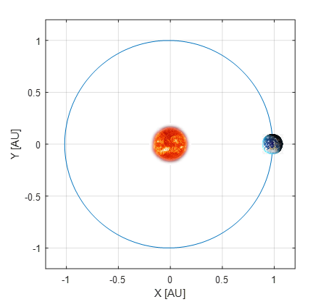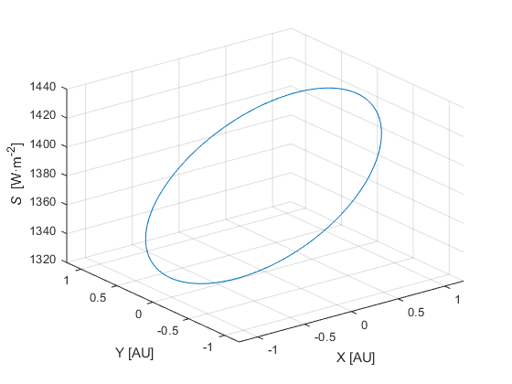

**Figure 4.5.4**: Earth orbit around Sun: distance $r$ representation (left); solar irradiance evolution in Earth orbit (right).

During the months in which this particular mission will take place (between September and April), the maximum and minimum values reached are 1426 and 1356 W/m2 respectively.

##### Albedo

$Q_{Albedo}$ is the fraction of the incident solar energy reflected off the Earth that arrives at the satellite. It is also a significant source of radiant energy when the spacecraft is near the planet.

|  |  |  |
| --- | --- | --- |
|  | $$Q_{Albedo}= αSRA_{R}$$ | (b) |

$A_{R}$ is the area exposed to the planet (Table 4.5.3) and $R$ is the percentage of solar irradiance diffusely reflected from the Earth. For this parameter, a typical value of 30% will be considered in the hot case, while for the cold case a value of 23% will be taken according to the references (Larson, s.d.).

##### Earth IR

$Q_{EarthIR}$ represents the planetary infrared energy, function of the planet’s temperature and the spacecraft orientation and material properties:

|  |  |  |
| --- | --- | --- |
|  | $$Q_{EarthIR}= εIRA_{IR}$$ | (c) |

where $ε$ is the emissivity of the material ($ε=0.84$), $A_{IR}$ is the area exposed to the Earth and $IR$ is the irradiance of infrared energy from Earth. According to the references, a value of 218 $W/m^{2}$ is going to be considered for the cold case and 244 $W/m^{2}$ for the hot case (Larson, s.d.).

Once all the contributions to the heat balance have been determined, the resulting equation is as follows:

|  |  |  |
| --- | --- | --- |
|  | $$σT^{4}εA_{tot}= αSA_{p}+ αSRA_{R}+εIRA_{IR}+Q_{inside}$$ | (2) |

|  |  |  |
| --- | --- | --- |
| Parameter | Hot Case | Cold Case |
| $$S\left[W/m^{2}\right]$$ | 1426 | 1356 |
| $$R\left[-\right]$$ | 0.3 | 0.23 |
| $$IR\left[W/m^{2}\right]$$ | 244 | 218 |
| $$Q_{inside}[W]$$ | 4 | 0.15 |

**Table 4.5.4**: Parameter values for the hot and cold case

Solving for variable $T$, the temperature estimation is obtained for each case. The results are collected in Table 4.5.5.

|  |  |  |
| --- | --- | --- |
|  | Hot Case | Cold Case |
| $$T[°C]$$ | 26.27 | 13.33 |

**Table 4.5.5**: Temperature results.

It can be seen how in the cold case the requirement that the temperature is higher than 11°C is always met, while in the hot case the established 21°C are exceeded, so some action will have to be carried out in order to place that value within the allowed range. It must be considered that these values are for the worst of the conditions, while the temperature for average values is of 18°C.

### Solar panels heat balance solution

At this point in the analysis, instead of assuming that the solar arrays will somehow affect the average temperature of the spacecraft through heat conduction, a preliminary proper selection of the hinge that attach the arrays to the main structure has been made to prevent this same phenomenon.

The study on which the latter decision has been based (Naimat, 2018) analyzes the thermal effects of large variations in solar panels’ temperature for different hinge materials collected in Table 4.5.6.

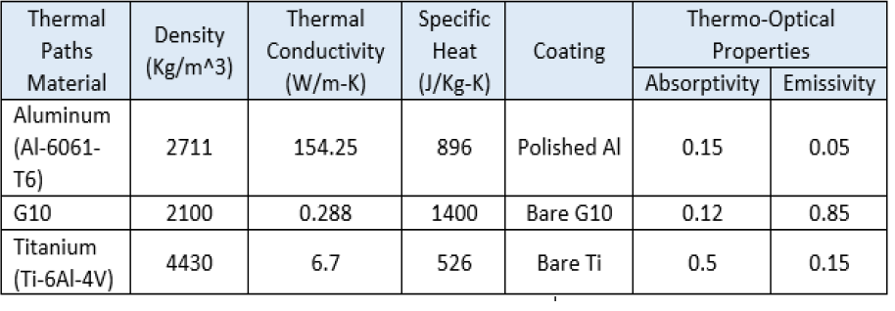

**Table 4.5.6**: Properties of the materials analyzed in the referenced study. (Naimat, 2018)

It has been proven that for materials with low conductivity, the spacecraft’s temperature remains practically constant, while materials with higher thermal conductivities could have important effects on the thermal equilibrium point of the main body. In Figure 4.5.5 it can be seen the temperature distribution between a solar panel and the main body of a spacecraft when it is exposed to large thermal variations.

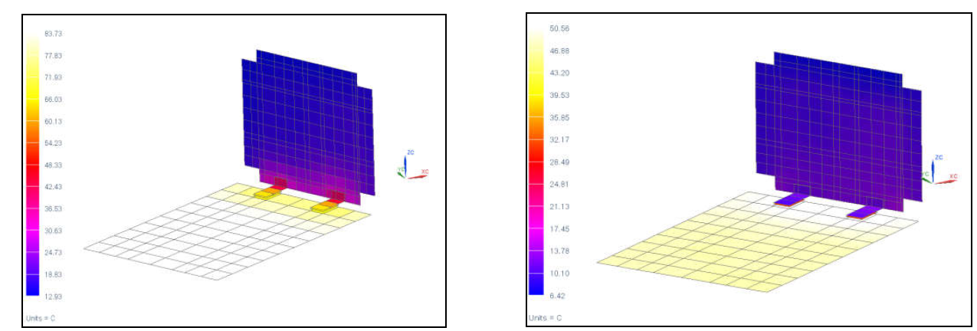

***Figure 4.5.5****: Temperature distribution with aluminum hinges (left) and titanium hinges (right).*

It has been proven that when trying to avoid a heat transfer between two components, the aluminum is not a good option. On the other hand, in Figure 4.5.6 is shown the temperature evolution in time when the spacecraft is exposed to a large temperature variation, comparing titanium alloy with G10, a composite material with a high-pressure fiberglass laminate.

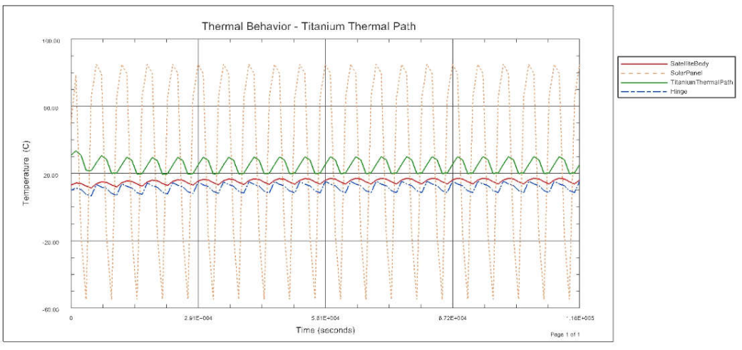

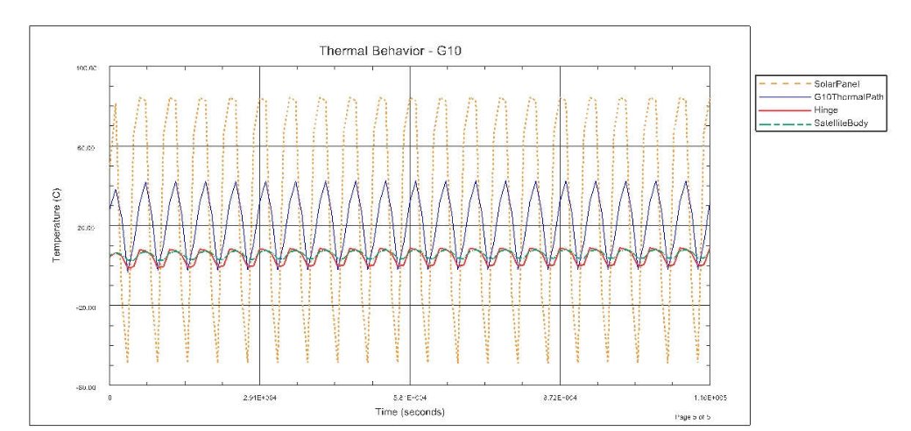

***Figure 4.5.6****: Temperature evolution in time when hinges material is titanium (top) or G10 (bottom).*

It can be concluded that by using G10 on hinges the spacecraft temperature variation due to solar panels heat conduction is practically negligible and, for this reason, this material has been selected for the hinges of the CubeSat.

### Thermal Control Solution: Louvers

Louvers are thermal control elements that have been used in different forms in numerous spacecraft. While they are mostly placed over external radiators, louvers may also find application to modulate radiant heat transfer between internal spacecraft surfaces and outer space. Louvers are widely used where internal power dissipation varies widely as a result of equipment duty cycles. However, in this mission where power dissipation is not expected to vary that much during operation, along with the fact that Sun-synchronous orbit provides great thermal stability, the reason to use louvers lies in the long-term cold operation period of the Earth around the Sun (low solar irradiance).

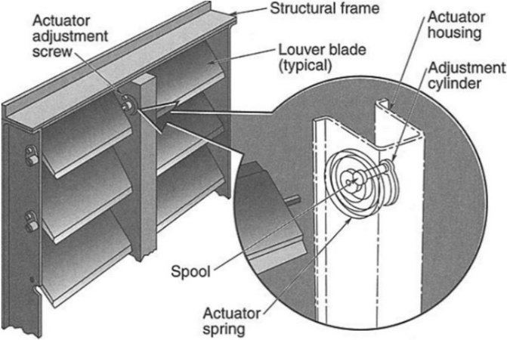

**Figure 4.5.7**: Fairchild and Northrop Louver Assembly Schematic.

Despite louvers are considered as active thermal control elements as actuators are used to deploy or retract the blades, there are also different designs that are based in passive actuation of flaps via bimetallic springs, requiring no power for thermal control.

CubeSat Form Factor Thermal Control Louvers use passive thermal control to significantly improve the internal thermal stability of small spacecraft, creating a difference of several watts in dissipated heat between open and closed louvers.



**Figure 4.5.8**: CubeSat Form Factor Thermal Control Louvers on a 6U CubeSat.

The difference in temperature between open/close state reaches several degrees, although this is all subjected to the configuration and size among other reasons. Also, the optical properties of the louver blades play a main role in the net heat balance of the spacecraft.

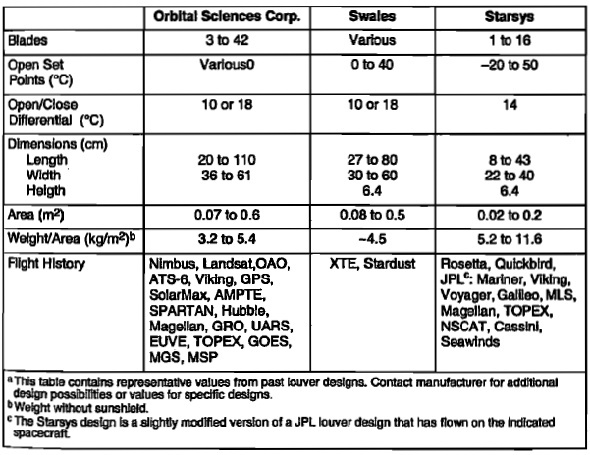

**Table 4.5.7**: Characteristics of Flight-Qualified Rectangular-Blade Louver Assemblies. Source [ (NASA Technology, s.d.)].

In conclusion, as no power is needed to activate the louver, the tailoring in the design, and the technology has been widely proven in the past, louvers seem a good option to finely tune the temperature in the spacecraft to its optimum throughout the whole mission. If the satellite, due to a combination of maximum energy received from environmental sources and maximum dissipation of the internal components is outside the allowed range, through these devices’ temperature could be kept within the ideal operating range for the radiometers. In the cold case, it has been verified before that it is not necessary to carry out any action since the temperature requirements are always fulfilled.

## Launcher

For the launcher election, the following options are considered:

### Vega

The Vega launcher is an expendable launch system developed for Arianespace jointly by the Italian Space Agency (ASI) and the European Space Agency (ESA). Vega is designed to launch small payloads including CubeSats. It can deliver 1500 kg into a circular Sun-synchronous orbit of 700 km altitude.

This option might be the most suitable one for this mission due to the following aspects: it is a small launcher, specifically designed to launch microsatellites and CubeSats; it is an European launcher, which can facilitate the necessary procedures; it is a more affordable option (each launch costs approximately $37M); and finally, there have been many CubeSats mission that used this launcher (for example VEGA VV16, with 46 CubeSats between 0.25U and 6U), which indicates that this launcher is a common option for this type of mission.

On the other hand, there are some negative aspects. Of the last three missions (VV15, VV16 and VV17), two of them ended up in failure and the mission was lost. This is a bad indicator of the reliability of the launcher. Nevertheless, these have been the only two failure’s mission in the history of Vega (17 launch).

In conclusion, Vega is a very suitable option for our mission.

### Soyuz

Soyuz launcher is also an expendable launcher. Version 2-1a, developed by Arianespace and launched from the Guiana Space Center has the capability to deploy up to 4450 kg to a SSO of 660 km of altitude, which is a lot over our target orbit.

This launcher is more expensive; however, it can be a suitable substitute in case that there were no available slots on a Vega. There are examples of successful launches of various microsatellites with a Soyuz, such as mission 89, which deployed 26 CubeSats and 2 MicroSats to three different SSO orbits. It has also the same advantage of being managed by Arianespace, thus having the administrative benefits of working with a European company.

The main drawback of this option is its highest price and bigger capacity in relation to Vega. This makes necessary to coordinate with more payloads in order to fill the launcher, and thus, keep the price of the launch affordable.

## Attitude Determination and Control System (ADCS)

The attitude determination and control subsystem is responsible for maintaining the desired orientation of the satellite at all points of the mission. This system is crucial to the success of the mission due to the high precision pointing requirements.

To determine the position and orientation of the satellite with the required precision (±10m, ±0.1deg), a GPS module and two star trackers will be selected. The star trackers will also have the added requirement of not being able to be switched on when they while facing the Sun.

To ensure that the sensors of the scientific payload and star trackers are not facing the Sun when they are turned on, six Sun sensors will be placed on each of the faces of the satellite. Should the sensor in one of the faces with a sensor detect the presence of the Sun that sensor will not be allowed to be switched on.

The satellite will suffer external perturbations during its orbit and will be forced to counteract them in order to point in the specified direction during its scientific readings. Three reaction wheels will be selected to act in three perpendicular axes to counteract these disturbances. To avoid the buildup of momentum in the reaction wheels, three magnetorquers will be placed to act in the same axes to dump momentum as well as magnetometers to measure the magnetic field in these directions. To size these elements an estimation of the magnitude of the disturbances will be performed. A factor 10% security factor will be used for the sizing of these components.

### Disturbance Estimation

Since the study is carried out from a preliminary phase, parameters corresponding to the worst possible cases have been used to determine the torques. The following sources of disturbance have been considered:

#### Gravity gradient torque

$$T_{g}=\frac{3μ}{r_{p}^{3}}|I_{max}-I_{min}|sin(2θ)$$

Gravity tends to orient a satellite’s longitudinal axis in the Nadir-Zenith direction. To estimate this perturbation the maximum and minimum moments of the satellite will be used ${(I}_{max}, I_{min})$ as estimated in the structure section***.*** The maximum vertical deviation $θ$ is the maximum angle between the longitudinal axis and Nadir-Zenith during operation.

#### Solar pressure torque

$$Tsp=\frac{Φ}{c}A_{sp}(1+q)cos(i)||c_{sp}-c_{g}||$$

Solar radiation generates a pressure on the satellite faces it falls upon. This pressure can be obtained with the parameter $\frac{Φ}{c}$ which includes the solar radiation flux from earth $Φ$ and the speed of light in a vacuum $c$. The torque it produces depends on the geometry of the satellite. Since the satellite is symmetric, the solar pressure center $c_{sp}$ is on the geometric center of the satellite. Therefore, the torque will depend on the center of mass of the satellite $c_{g}$. The area affected by the solar radiation ${(A}_{sp)}$ will depend on the orientation of the satellite and the area of the solar panels that will be calculated on the power section. The coefficient of reflectivity of the surface $(q)$ will depend mainly on the solar panels and will be obtained from the power module. Finally, it will be assumed that the angle of incidence of the Sun $(i)$ will be 0° which will be the position in which the greatest amount of energy is obtained and worst case scenario for the attitude control systems.

#### Aerodynamic torque

$$Ta=\frac{1}{2}ρ_{atm,p}C_{D}A_{a}V_{p}^{2}||c_{a}-c_{g}||$$

Aerodynamic drag is usually the main source of disturbances in low orbits such as this satellite. The atmospheric density at the height of the orbit will be obtained using a model developed by the United States Air Force [**RD6**] and the worst case of maximum density corresponding to periods of maximum solar activity will be assumed. To model the satellite, simplification has been used as a flat plate in which the coefficient of aerodynamic drag is 1.28 for hypersonic speeds with the center of pressures at the geometric center of the face in the direction of speed. The frontal area in the speed direction will be that corresponding to two CubeSats given the orientation of the satellite during flight. Finally, the speed of the satellite will be obtained from mission analysis while the center of gravity of structures.

#### Magnetic Torque

$$T_{m}≈D_{m}\frac{λM_{m}}{r_{p}^{3}}$$

The Earth's magnetic field generates a toque on the satellite if it has a residual dipole from its electrical devices. In practice the residual dipole $D_{m}$ of a satellite is obtained experimentally and not estimated, although there are processes to reduce it. A representative 0.1 value will be assumed which is common for a CubeSat of this size. The earth’s magnetic moment $M_{m}$ is approximately 7.96·10¹⁵ T·m³. The parameter $λ$ is a unitless function that represents the magnetic latitude, which is 2 at the poles.

### Results

| Parameters |  |
| --- | --- |
| Altitude | 550 km |
| Orbit Velocity | 7.585 km/s |
| Maximum vertical deviation | 5.1° |
| Solar Inclination | 0° |
| Area | 0.12 m2 |
| Maximum moment of inertia | 0.05 kg m2 |
| Minimum moment of inertia | 0.016 kg m2 |
| Center of mass of the satellite | 0.068 m |
| Center of solar pressure | 0 m |
| Center of aerodynamic pressure | 0 m |
| Superficial reflectiveness coefficient | 1 |
| Aerodynamic drag coefficient | 1.28 |
| Latitude magnetic coefficient | 2 |
| Residual Magnetic dipole | 0.1 |

***Table 4.7.1****: Parameters used in ADCS characterization.*

The following results have been obtained from repetitive concurrent design iterations.

|  |  |
| --- | --- |
| Disturbance | Torque (µN·m) |
| Gravity gradient | 0.01086 |
| Solar pressure | 5.476 |
| Aerodynamic | 9.604 |
| Magnetic | 0.07436 |
| **Total** | **15.166** |

***Table 4.7.2****: Estimated disturbance torques.*

These moments, added to the moment necessary to rotate the satellite in such a way that it always points with the same face at nadir and at zenith, mean that a torque of 18.199 µN·m is required on the reaction wheels to make this change in orientation.

The moments stored in the reaction wheels for this maneuver are of the order of 18.406 mN·m·s. Undoubtedly the latter is decisive when selecting the actuator, although the use of magnetorquers can relax this requirement.

The minimum magnetic dipole of the magnetometers has been determined equivalently as the magnetic torque.

### Equipment Selected

The following sensors and actuators have been selected from the design process:

#### Attitude determination

##### NSS GPS Receiver

|  |  |  |  |  |  |  |  |  |  |
| --- | --- | --- | --- | --- | --- | --- | --- | --- | --- |
| |  |  | | --- | --- | | Position accuracy | <10m (3D RMS) | | Dimensions | 96mm x 96mm x 15mm | | Mass | <110 g | | Power | 1W (excluding active antenna) |   ***Table 4.7.3****.* GPS *Module properties.* | **Figure 4.7.1**: GPS Module |

##### Nano-SSOC-A60 analog Sun sensor

|  |  |  |  |  |  |  |  |  |  |  |  |
| --- | --- | --- | --- | --- | --- | --- | --- | --- | --- | --- | --- |
| |  |  | | --- | --- | | Accuracy | <0.5 deg (3-Sigma) | | Precision | <0.1 deg | | Dimensions | 27.4 x 14 x 5.9 mm | | Mass | 4 g | | Power | 3.3V or 5V with <2 mA (average) |   ***Table 4.7.4****: Sun Tracker properties.* | **Figure 4.7.2**: Sun Tracker |

##### arcsec Twinkle star tracker

|  |  |  |  |  |  |  |  |  |  |  |  |
| --- | --- | --- | --- | --- | --- | --- | --- | --- | --- | --- | --- |
| |  |  | | --- | --- | | Accuracy | 15 arc seconds (1 sigma) cross-boresight, 90 arc seconds (1 sigma) around boresight | | Precision | <0.1 deg | | Dimensions | (20x20x40) mm | | Mass | 250 g | | Power | < 1 W (+5V required) |   ***Table 4.7.5****: Star Tracker properties.* | **Figure 4.7.3**: Star Tracker |

##### NSS Magnetometer

|  |  |  |  |  |  |  |  |  |  |  |  |
| --- | --- | --- | --- | --- | --- | --- | --- | --- | --- | --- | --- |
| |  |  | | --- | --- | | Resolution | <8 nT | | Orthogonality | ± 1° | | Dimensions | 96x43x17mm | | Mass | 85g | | Power | < 750 mW |   ***Table 4.7.6****: Magnetometer properties.* | **Figure 4.7.4**: Magnetometer |

#### Control System

##### CubeWheel Medium

|  |  |  |  |  |  |  |  |  |  |  |  |
| --- | --- | --- | --- | --- | --- | --- | --- | --- | --- | --- | --- |
| |  |  | | --- | --- | | Max torque | 2.3 mNm | | Momentum storage (@6000 RPM) | 30.0 mNms | | Dimensions | 57 x 57 x 31.5 mm | | Mass | 200 g | | Power | <180 mW (@2000 RPM, 8V) |   ***Table 4.7.7***: *Reaction wheel properties* | **Figure 4.7.5**: Reaction wheel |

##### NCTR-M002 Magnetorquer Rod

|  |  |  |  |  |  |  |  |  |  |  |  |
| --- | --- | --- | --- | --- | --- | --- | --- | --- | --- | --- | --- |
| |  |  | | --- | --- | | Magnetic moment | > 0.2 Am2 | | Residual moment | <0.001 Am2 | | Dimensions | 70mm (length) x 9 mm (diameter) | | Mass | < 30 g | | Power | 200mW from 5V supply |   ***Table 4.7.8****: Magnetorquer properties.* | **Figure 4.7.6**: Magnetorquer |

## Electric power subsystem

This subsystem must provide the required power to the whole spacecraft. The total power required depends on the satellite’s equipment and it is necessary to analyse the power needs of each subsystem.

|  |  |  |  |  |  |
| --- | --- | --- | --- | --- | --- |
| Subsystem | Payload (Radiometers and micro-propulsion) | Thermal control | ADCS | Communications | Computer |
| Power (W) | 30 | 0 | 3.89 | 6.5 | 0.4 |

**Table 4.8.1**: Power needs of each subsystem

If every subsystem were turned on at the same time, the total power would reach 40.79 W. It is almost impossible to generate this amount of power in our small CubeSat. In order to solve this problem, it is advisable to define the *system operational modes*. These modes are different operational choices which constraint the maximum power under a threshold, that is limited by the solar cells.

Once a preliminary mission analysis has been carried out, four modes has been defined to allocate the whole power requirements in different stages within the satellite’s operational life. These modes are shown in the table below:

|  |  |  |  |  |  |  |  |  |
| --- | --- | --- | --- | --- | --- | --- | --- | --- |
| Subsystem | **Payload: radiometers** | **Payload: micro-propulsion** | **Thermal control** | **ADCS** | **Communications** | **Telemetry** | **Computer** | **Total power (W)** |
| Power (W) | 10 | 20 | 0 | 3.89 | 4.5 | 2 | 0.4 | 40.79 |
| Modes | | | | | | | | |
| Stage 1 | X |  | X | X |  | X | X | 16.29 |
| Stage 2 |  | X | X | X |  | X | X | 26.29 |
| Data transmission |  |  | X | X | X | X | X | 10.79 |
| Safe mode |  |  | X | X |  | X | X | 6.29 |

**Table 4.8.2**: System operational modes

This analysis shows that the maximum power required will be 26.29 W, during the stage 2 (functioning period of the micro-propulsion payload), and the minimum 6.29 W, during the safe mode (only essential subsystems are active).

The battery and the solar cells of the power subsystem have been sized to fulfil these requirements.

The *electric power subsystem* produces power dissipation on the spacecraft, which must be had into account in the design of the *thermal control subsystem*. The estimated power dissipation depends on the operational mode, but it reaches a maximum of 1.98 W and a minimum 0.15 W.

### Energy storage

While our satellite is eclipsed by the Earth, the input solar power in the solar cells is zero. The only way to supply this energy during eclipse periods, in small satellites, is to use a battery to storage the energy required. Even if there were not any eclipse, the battery could supply power when the most demanding operational modes are active. The battery selected for this mission is the model *EPS I PLUS* by *Endurosat.* This battery is specifically designed to be used in CubeSats and it has a flight heritage. It is compact, very efficient and has undergone space qualification testing. Furthermore, it is one of the batteries suggested by NASA, applicable to CubeSats. The main features of this battery will be explained in detail:

* **Type**: We have selected a Li-ion battery, whose energy density is 150 W h/kg.
* **Transmission efficiency**: We have selected an efficiency of 0.9, so small losses are considered.
* **Number of charge-discharge cycles**: It depends on the selected orbit and the mission duration. In this case, there will be 138 cycles.
* **Depth of discharge**: Limited to 70 % to avoid early degradation.
* **Bus voltage**: Limited by the battery performances to 5 V.
* **Battery capacity**: The selected battery has a capacity of 10.2 W h or 2.04 A h (the conversion is carried out with the bus voltage).
* **Maximum current**: Limited to 1.8 A per solar panel channel.
* **Mass**: The total mass is the sum of the masses of the battery cells and other components, such as the power control system, switches, interfaces with the solar arrays, etc. The total mass is 298 g.
* **Price**: 3300 €.

This battery is one of the smallest made for CubeSats and, however, it is oversized. This mission has been designed to avoid any eclipse during the operational stage; however, a possible eclipse time has been considered for the power subsystem design, in case that there was a change of the launch window. The maximum eclipse duration considered for this mission will be 18.38 min due to the Sun-synchronous orbit selected, but there will be several days without any eclipse. This fact makes that the battery is fully charged during long periods of time and its degradation is minimum. Moreover, during an 18 min eclipse this battery can supply 34 W, what is more than the power required for the most severe operational mode.

All these results show that this battery is adequate for this mission and it fulfils all the requirements imposed by the other subsystems.

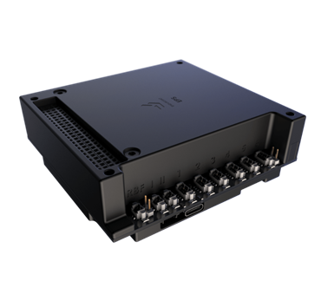

**Figure 4.8.1**: Battery EPS I PLUS by Endurosat

### Solar arrays

The design of the solar panels has been influenced by parameters related to the orbital period, the maximum eclipse time during the mission, as well as how long the mission will last, which will influence the degradation of the panels.

Mainly, the design of the solar arrays consisted of searching for panels whose characteristics fulfil the requirements depending on the maximum area available.

To achieve the power requirements during daylight and eclipse periods, we concluded that it was necessary to use high quality solar cells and panels with as much area as possible. Therefore, the option chosen was to deploy two panels that would initially be placed on the two faces that contains the six units of the CubeSat.

With this idea, as each unit has dimensions of 0.1 m x 0.1 m, each of its faces has an area of 0.01 m2. Then, on a full side of the satellite a panel of 0.06 m2 can be placed, which together with the other side, it is obtained a maximum available area of solar panels of 0.12 m2.

The solar cells selected for this mission are Z4J from SolAero. These cells are optimized for all space missions and are fully space qualified. Their main features are shown below:

* **Type**: 4-junction n-on-p solar cell on germanium substrate. Flat panel deployed.
* **Efficiency**: 30%, which is a very high efficiency.
* **Solar array area**: 0.101 m2.
* **Cell nominal voltage**: 3.54 V.
* **Total Power**: 6.94 W.
* **Mass:** the total mass of the solar arrays includes the cells and wiring, and it is 820 g.

In addition, as mentioned above, high-quality panels are needed to meet power requirements, so high transmission efficiencies during Sunlight and eclipse have been selected, being 85% and 70% respectively. Also, an inherent degradation value of 80% has been chosen, which is a typical value that allows to meet the area requirements.

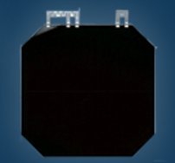

**Figure 4.8.2**: SolarAero Z4J cells

# Risk Management

## Risk Nomenclature

In order to recognize and organize the risks exposed within this document they have been classified as the follows:

XXX-YYY

Where ‘XXX’ stands for risk category label (classified in the following table) and ‘YYY’ is the number which designs the risk in the category.

|  |  |
| --- | --- |
| Risk category | ACRONYM |
| Mission risks | MIS |
| Communication subsystem and ground segment risks | COM |
| Thermal control subsystem risks | TCS |
| Attitude Determination and Control System risks | ADC |
| Structural and OBDH risks | STR |
| Power risks | POW |

***Table 5.1.1****: Risk categories*

## Risk Classification and Management

Risk can be evaluated according to two different factors. The first one is the severity of its consequences, and the second one is the actual likelihood it is taking place.

|  |  |  |
| --- | --- | --- |
| Score | Severity | Severity of consequence |
| 5 | Catastrophic | Any objective can be achieved |
| 4 | Critical | Several objectives cannot be accomplished but at least one can be achieved |
| 3 | Major | One mission objective cannot be accomplished |
| 2 | Significant | One mission objective could be compromised |
| 1 | Negligible | It does not compromise any objective |

***Table 5.2.1****: Risk classification by severity*

|  |  |  |
| --- | --- | --- |
| Score | Likelihood | Likelihood of occurrence |
| E | Maximum | Certain to occur, will occur one or more times per project |
| D | High | Will occur **frequently**, about 1 in 10 projects |
| C | Medium | Will occur **sometimes**, about 1 in 100 projects |
| B | Low | Will **seldom** occur, about 1 in 1000 projects |
| A | Minimum | Will **almost never** occur, 1 of 10 000 or more projects |

***Table 5.2.2****: Risk classification by likelihood.*

According to these classifications the risks will be labeled with an index considering both factors.

|  |  |  |  |  |  |  |
| --- | --- | --- | --- | --- | --- | --- |
| Likelihood |  |  |  |  |  |  |
| E | Medium | Medium | High | Very High | Very High |  |
| D | Medium | Medium | Medium | High | Very High |  |
| C | Low | Medium | Medium | Medium | High |  |
| B | Very Low | Low | Medium | Medium | Medium |  |
| A | Very Low | Very Low | Very Low | Low | Medium |  |
|  | 1 | 2 | 3 | 4 | 5 | Severity |

***Table 5.2.3****: Risk classification according to their severity and their likelihood.*

Finally, depending on its index, each risk will be managed according to the following table:

|  |  |  |
| --- | --- | --- |
| **Risk index** | **Risk magnitude** | **Proposed actions** |
| E4, E5, D5 | Very High risk | Unacceptable risk: implement new team process or change baseline – seek project management attention at appropriate high management level as defined in the risk management plan. |
| E3, D4, C5 | High risk | Unacceptable risk: see above. |
| E1, E2, D1, D2, D3, C2, C3, B3, B4, B5, A5 | Medium risk | Unacceptable risk: aggressively manage, consider alternative team process or baseline – seek attention at appropriate management level as defined in the risk management plan. |
| C1, B2, B4, A4 | Low risk | Acceptable risk: control, monitor – seek responsible work package management attention. |
| A1, A2, A3 | Very Low risk | Acceptable risk: see above. |

**Table 5.2.4**: Example of risk magnitude designations and proposed actions for individual risks

## Risk Analysis

### Mission risks

| ID: **MIS-001** | **Inaccurate orbital injection** | | |
| --- | --- | --- | --- |
| **SCENARIO** | | | |
| Causes and consequences: | Launcher deploys the satellite with an inadequate altitude, inclination or RAAN.  The orbit will not be the nominal one, causing a reduction on the duration of the mission and a smaller number of accesses to the poles. | | |
| Magnitude: | Severity | Likelihood | Risk index |
| 2 | B | Low |
| **DECISION AND ACTION** | | | |
| Accept Risk: | R | Reduce Risk: |  |
| Considerations: | No actions needed. | | |

|  |  |  |  |
| --- | --- | --- | --- |
| ID: **MIS-002** | **Catastrophic failure of the launcher** | | |
| **SCENARIO** | | | |
| Causes and consequences: | Launcher and mission lost. | | |
| Magnitude: | Severity | Likelihood | Risk index |
| 5 | A | Medium |
| **DECISION AND ACTION** | | | |
| Accept Risk: | R | Reduce Risk: |  |
| Considerations: | No actions possible. | | |

### Communication subsystem and ground segment risks

|  |  |  |  |
| --- | --- | --- | --- |
| ID: **COM-001** | **Insufficient system link margin** | | |
| **SCENARIO** | | | |
| Causes and consequences: | Higher propagation losses than considered due to adverse weather (thunderstorm).  Not all the information is received intelligible and with an adequate signal-to-noise ratio. | | |
| Magnitude: | Severity | Likelihood | Risk index |
| 4 | B | Medium |
| **DECISION AND ACTION** | | | |
| Accept Risk: |  | Reduce Risk: | R |
| Action/Reduction measures: | Consider a back-up ground station in case the link is affected.  Enough storage capacity onboard. | | |

|  |  |  |  |
| --- | --- | --- | --- |
| ID: **COM-002** | **Antenna or transceiver malfunction** | | |
| **SCENARIO** | | | |
| Causes and consequences: | Overheated antenna due to wrong thermal calculation. Not enough power for transceiver.  No communication with the ground station, loss of data. | | |
| Magnitude: | Severity | Likelihood | Risk index |
| 4 | A | Low |
| **DECISION AND ACTION** | | | |
| Accept Risk: | R | Reduce Risk: |  |
| Considerations: | The risk must be accepted as CubeSats are designed with no redundancy criteria on communication elements. The risk is very unlikely due to very high technology readiness level of the equipment. | | |

### Thermal control subsystem risks

|  |  |  |  |
| --- | --- | --- | --- |
| ID: **TCS-001** | **Louvers malfunction** | | |
| **SCENARIO** | | | |
| Causes and consequences: | A failure in the bimetallic springs of the louvers will prevent the flaps’ from opening and closing. If this happens, it will not be possible to evacuate heat and/or regulate temperature in the spacecraft. This may lead to leave the temperature allowable range, so the established requirements won’t be met. | | |
| Magnitude: | Severity | Likelihood | Risk index |
| 4 | C | Medium |
| **DECISION AND ACTION** | | | |
| Accept Risk: |  | Reduce Risk: | R |
| Action/Reduction measures: | Consider redundant systems. | | |

### Attitude Determination and Control System risks

|  |  |  |  |
| --- | --- | --- | --- |
| ID: **ADC-001** | **Sensor failure.** | | |
| **SCENARIO** | | | |
| Causes and consequences: | Attitude determination compromised, wrong pointing of the spacecraft. | | |
| Magnitude: | Severity | Likelihood | Risk index |
| 3 | A | Very low |
| **DECISION AND ACTION** | | | |
| Accept Risk: |  | Reduce Risk: | R |
| Action/Reduction measures: | Consider redundant systems. | | |

|  |  |  |  |
| --- | --- | --- | --- |
| ID: **ADC-002** | **Actuator degradation.** | | |
| **SCENARIO** | | | |
| Causes and consequences: | Due to space exposure (radiation, temperature, …) and operation magnetorquers and reaction wheel’s motors could suffer degradation thus leading into a situation where more power would have to be delivered to ACDS subsystem. | | |
| Magnitude: | Severity | Likelihood | Risk index |
| 1 | D | Medium |
| **DECISION AND ACTION** | | | |
| Accept Risk: |  | Reduce Risk: | R |
| Action/Reduction measures: | Reserve more power for ADCS subsystem. | | |

|  |  |  |  |
| --- | --- | --- | --- |
| ID: **ADC-003** | **Collision with space debris.** | | |
| **SCENARIO** | | | |
| Causes and consequences: | A critical change in attitude can occur if the spacecraft collides with large pieces of space debris. If sensors are working at this time the unforeseen Sun-exposition could destroy or damage sensors. | | |
| Magnitude: | Severity | Likelihood | Risk index |
| 4 | A | Low |
| **DECISION AND ACTION** | | | |
| Accept Risk: | R | Reduce Risk: |  |
| Considerations: | The risk must be accepted because the spacecraft has no propulsion system. Perhaps a spin stabilization before a predicted crash could reduce the magnitude of the attitude perturbation whereas sensors shutdown would protect it from solar exposure. | | |

### Structural risks

|  |  |  |  |
| --- | --- | --- | --- |
| ID:**STR-001** | **On-board computer runs out of memory.** | | |
| **SCENARIO** | | | |
| Causes and  consequences: | Due to a long time without having access to ground station the on-board computer data storage runs out of space and, therefore, losses collected data. | | |
| Magnitude: | Severity | Likelihood | Risk index |
| 1 | A | Very Low |
| **DECISION AND ACTION** | | | |
| Accept Risk: | R | Reduce Risk: |  |
| Considerations: | Selecting a ground station with a high latitude to ensure frequent access and choose an on-board computer with enough space in case of any inconvenience occurs with the ground station. | | |

### Power risks

|  |  |  |  |
| --- | --- | --- | --- |
| ID: **POW- 001** | **Power distribution system failure** | | |
| **SCENARIO** | | | |
| Causes and consequences: | The possible failure of some electrical devices could lead to an inappropriate power distribution and a bad functioning of some of the satellite subsystems. | | |
| Magnitude: | Severity | Likelihood | Risk index |
| 3 | B | Medium |
| **DECISION AND ACTION** | | | |
| Accept Risk: |  | Reduce Risk: | R |
| Action/Reduction measures: | The use of redundant electrical components is an extended good praxis in space systems, and it allows to assure that a *double failure* is needed to damage the system. | | |

|  |  |  |  |
| --- | --- | --- | --- |
| ID: **POW- 002** | **Failure in deployment of solar arrays** | | |
| **SCENARIO** | | | |
| Causes and consequences: | The possible failure in the deployment of solar arrays could have a strong impact in the mission because the subsystems of the satellite could not receive the power needed for their operation. | | |
| Magnitude: | Severity | Likelihood | Risk index |
| 5 | B | Medium |
| **DECISION AND ACTION** | | | |
| Accept Risk: |  | Reduce Risk: | R |
| Action/Reduction measures: | The use of redundant mechanisms is a way to reduce risk, because if the main mechanism fails, the redundant one can be used, and the mission can continue. | | |

# Conclusions

## Mission Analysis and Launcher

The proposed orbit for the mission is:

* Sun-Synchronous LAN 18 (Dusk-Dawn), with a local time of ascending node at 18:00 (and a local time of descending node at 06:00). Critical for requisite R-100 (Zenith antennas should have a FOV of 90° free of the Sun).
* Altitude: 550 km. This value is flexible. Studies at different altitudes (450 and 500 km) have been made. Lower altitudes may increase the mission duration, but probably, the altitude will be selected when the launcher is established.
* Mission duration: 1 September - 15 April. This duration is limited by the eclipses period that begin in May for this orbit with a maximum in June.
* Sun incidence: the zenith sensor must have a minimum inclination of 15 deg. Larger inclination could extend the mission duration, but a study should be carried out to determine if those larger inclinations, at structural point of view, are possible to obtain and to confirm that the sensor is free of the Earth and spacecraft obstacle.
* Accesses to the poles: The number of accesses to a region of 500 Km around the magnetic poles is compliant with the mission requisites. It is not necessary to increase the radius of the area studied.
* Accesses to the ground station: The location of the chosen ground station, close to the north pole, ensures that the satellite is going to have frequent accesses with it.
* Measurements duration: in the worst case (550 km) we achieve 59 days of measurements.

For the launcher selection, two options are given:

* VEGA: it is one of the most common option for small satellites. Furthermore, there are precedents of CubeSats launches from VEGA recently (mission VV116). The fact that it is an European launcher and it, relatively, low cost, make it a very suitable option.
* Soyuz: even though it is intended for bigger and heavier payloads, the Soyuz retains the advantages of being a launcher that works with the European Space Agency. It has a good flight record; some CubeSat missions have been successfully launched with them.

## Mechanical Design and Structure

Based on the final configuration of the platform, many conclusions have been obtained:

* Components location is not a trivial problem, each component has its own requirements of positioning or accessibility and sometimes not every of them can be satisfied. Also, as an added difficulty, it is imperative to accomplish CubeSat specifications and take on account that wiring should be possible. There is not a unique solution, but more than finding the best one, this preliminary design was about proving all the components fit on the structure and achieve their purposes.
* Exceed the mass margin entails a series of consequences that implies a cost increase. It is very important to have under supervision the mass budget during the successive phases, so it does not exceed the limit stablished by CubeSat standards or launcher specifications.

## Communication subsystem and ground station

According to the budget calculations, the conclusions are:

* The uplink margin is 22,36 dB and 4,81 dB for the downlink. Since both margins are positive, it is ensured that all the information will be received with an adequate signal-to-noise ratio.

According to the ground station selection:

* The access report shows that the average access time is 2 minutes. However, various access take place throughout the day. For that reason, the data transfer is feasible in terms of data rate, which is 20 kbps.

## Thermal Control subsystem

The following conclusions have been reached regarding the thermal behavior:

* The Sun-synchronous orbit in which the spacecraft is located, together with the absence of eclipses, make the **thermal environment** to which the satellite is exposed **very stable** throughout the entire development of the mission.
* A **thermal balance** has been carried out for the spacecraft to estimate its temperature, both for the **cold and hot case** found along the mission.
* It has been proved that **black paint 3M Black Velvet**, which has an emissivity of 0.84 and an absorptivity of 0.97, is the most suitable surface finish for the satellite outer faces in accordance with the thermal conditions.
* The analysis of the extreme operational scenarios, the hot and the cold case, which both depend on the environmental conditions and the internal power dissipation, demonstrate that the **cold case temperature** of the spacecraft **is 13°C** whereas in the **hot case** it **is 26°C**.
* Despite the lowest temperature allowed is fulfilled, this is 11°C according to the requirements, the upper 21°C limit is exceeded. **Temperature requirement** is not fully met.
* As for the **solar arrays' hinges**, a suitable choice that provide good thermal isolation between the spacecraft body and the solar panels is **material G10**.
* To correct the excess in temperature in the hot case, **the use of louvers is proposed**. This way heat can be naturally controlled and dissipated, introducing slight variations in temperature so that the spacecraft remains within the allowable range. Besides, it does not demand any additional power as long as implementing form factor materials to actuate the flaps.

## Attitude Determination and Control Systems

According to the results obtained in the study of the ACDS subsystem the following conclusions had been extracted:

* The disturbance torque, which is about 15.166 µN·m, can be largely counteracted by the actuators available on the market. The main of these perturbations is the aerodynamic force due to the low altitude.
* Momentum storage could be the most demanding requirement (it is around 18.406 mN·m·s), as the spacecraft must continuously rotate to focus on the earth with its sensors, but that requisite can be lowered using magnetorquers.
* To meet the strict requirement for accuracy in aiming (0.1 deg), an advanced attitude determination system must be included (such as a Star Tracker).

## Power Subsystem

The design of the power subsystem has consisted in the selection of the battery and the solar cells that assure the compliance of the requirements of the mission. Different modes of operation have been considered to estimate the amount of power that all the subsystems are going to use.

* The battery selected has been a Li-ion battery, which is one of the smallest made for CubeSats, but ensure the supply of power for all subsystems in each operational mode.
* Solar arrays have been designed to be deployable, to guarantee that they do not interfere with other instruments of the satellite. In addition, the selected cells for the panels are of high quality, their efficiency is of 30%, because the small size of the CubeSat causes a very reduced area to place the panels.